

DAEN 690

Project Report

Jainam Rajesh Jagani

Varsha Monala

Ivan Francis

Sai Manish Reddy Pannala

Veena Bathula

Fall 2024

Puerto Rico Sea Level Rise Centre – Data Portal Dashboard

**About the Cover**

James Baldo is an associate professor and serves as the Director of the George Mason University (GMU), College of Engineering and Computing (CEC), Volgenau School of Engineering (VSE), MS Data Analytics Engineering (DAEN) program. Dr. Baldo has served in this position since Fall 2018 and recently returned this past May after a 2-year sabbatical applying state-of-the-art data analytics engineering concepts and technologies to solve real world problems.

Prior to becoming director of the DAEN program he served 19 years as a CEC adjunct professor while working as a practicing engineer. His career has over 45 years of industry and government experience with roles as a data analytics engineer and software engineer.

His interest in large scale data, data management, analytics, and tools has provided him with opportunities to engage in assessing and applying new technologies across a diverse range of problems. The adoption of new technologies is exciting; however, adoption of new technologies requires careful planning and in addition to the technology, taking special care for planning how to successfully address for both organizational and cultural factors of the enterprise. This requires not only engineering knowledge and skills, but the ability to work on teams that interact across different corporate stakeholders.

Dr. Baldo continues to consult part-time with industry and leverages this knowledge and experience as feedback to the DAEN program. With technology moving at a lightening pace and technology adoption rates increasing, Dr. Baldo closely monitors the skillset needs of industry and how the DAEN program can provide graduates to fulfill these needs.

Dr. Baldo is currently researching applications of data mesh and data fabric for data management and exploring how analytics will be integrated into agentic systems.

Contents

Table of Contents

Abstract 1

Section 1: Introduction 3

1.1 Report Purpose 3

1.2 Report Readership 3

1.3 Report Structure 3

Section 2: Problem Definition 4

2.1 Problem Space 4

2.2 Research 7

2.3 Solution Space 8

2.4 Project Objectives 9

2.5 Primary User Stories 9

2.6 Product Vision 9

2.6.1 Scenario #1 9

2.6.2 Scenario #2 10

Section 3: Datasets 10

3.1 Overview 10

3.2 Field Descriptions 11

3.3 Data Context 13

3.4 Data Conditioning 14

3.5 Data Quality Assessment 15

3.6 Other Data Sources 16

3.7 Storage Medium 17

3.8 Storage Security 17

3.9 Storage Costs 17

Section 4: Dashboard Development and Data Integration 17

4.1 Dashboard Design and Data Integration. 17

4.1.1 Dashboard Structure 17

4.1.2 Data Integration Process 20

4.2 Analytical Insights and Exploration 22

4.2.1 Analytical Approach 22

The analytical approach for this project integrates multiple dimensions of risk assessment to develop actionable insights for infrastructure resilience, resource allocation, and emergency preparedness. By focusing on infrastructure tier analysis, county-level vulnerabilities, and shelter capacities, the analysis ensures that stakeholders are equipped with precise, data-driven recommendations to address Puerto Rico’s unique challenges. 22

4.2.2 Insights for Stakeholders 24

4.3 Solution Implementation 25

4.3.1 Dashboard Features 25

4.3.2 Spatial and Analytical Tools 26

4.3.3 Data Flow and Updates 28

Section 5: Visualizations 30

5.1 Visualization – FEMA Data 30

5.2 Visualizations – Internal Dataset(PRSTRT) 37

5.3 Visualization – School Shelters Data 40

Section 6: Findings 40

Section 7: Summary 42

Section 8: Future Work 43

Appendix A: Domain Background 47

Appendix B: Glossary 51

Overview 52

GitHub Repository Link 52

GitHub Repository Contents 52

Appendix D: Risks 53

Sprint 1 Risks 53

Sprint 2 Risks 53

The team identified several key risks in the data management process. Data unavailability, while low in probability but high in impact, could result in critical datasets being inaccessible, so the team plans to use backup datasets and maintain communication with providers to mitigate this. Data quality issues, such as missing or incorrect data, will be addressed through rigorous validation and cleaning procedures before each sprint. Inconsistent data formats, which have a low probability but medium impact, will be managed by standardizing formats during data preprocessing and documenting changes. To prevent the risk of outdated data, the team will verify dataset recency and explore alternative sources as needed. Lastly, data integration errors, arising from combining multiple datasets, will be tackled through early technical tests to ensure compatibility of tools, minimizing the chances of integration issues. 54

Sprint 3 Risks 54

The team identified several critical risks in the data integration and dashboard development process. Validating datasets was a high-priority risk, given the potential for incomplete or inaccurate data and delays in validation. To mitigate this, the team plans to implement rigorous validation protocols and use multiple data sources for verification. The embedding of disaster data, including flood risks and sea level changes, also posed a high risk due to potential inconsistencies across data sources. This risk will be managed by cross-checking data with the client and applying consistent data standards to ensure reliability. 55

The team also recognized the challenge of mapping and integrating various datasets into ArcGIS, where medium-probability integration errors could have a high impact. To prevent this, the team will conduct detailed mapping and integration tests, validating the results against known benchmarks. In addition, the creation of a priority system for public infrastructure introduced a high-probability risk of improper resource allocation. This will be addressed by using advanced algorithms and coordinating with the client to align priorities. 55

Finally, translating the data into a user-friendly dashboard was identified as a medium-probability, medium-impact risk due to potential challenges in data visualization and user interface design. To mitigate this, the team will conduct usability testing and apply iterative design improvements, ensuring the dashboard remains intuitive and effective for users. 55

Sprint 4 Risks 55

During the sprint, the team effectively addressed several risks to ensure the successful delivery of the project dashboard. High-impact risks like data integration issues and performance lags were mitigated by validating and preprocessing datasets, optimizing queries, and using caching to streamline operations. Medium-level risks, such as real-time data instability and inconsistent refresh rates, were managed by employing cached backups, monitoring disruptions, and standardizing update intervals. Additionally, simplifying the user interface and testing with users helped mitigate confusion caused by complex visuals. Lastly, the team maintained regular updates and tests for library dependencies to avoid compatibility issues. These actions underscored the importance of early validation, continuous monitoring, and user-focused design in mitigating risks effectively. 56

Sprint 5 Risks 56

Appendix E: Agile Development 57

Scrum Framework Team Approach 57

Sprint 1 Lessons Learned 57

Sprint 2 Lessons Learned 57

During this sprint, the team learned valuable lessons in both risk management and working with datasets. To mitigate data unavailability, maintaining clear communication with providers and using backup datasets ensured the workflow remained smooth. Addressing data quality issues early by implementing rigorous validation and cleaning processes helped prevent errors and rework. The team also discovered the importance of standardizing data formats and documenting changes during preprocessing to facilitate collaboration and avoid confusion later on. Regular checks for outdated data ensured the team worked with relevant, timely datasets, improving the accuracy of their results. Early testing of tools and data compatibility helped streamline the integration of multiple datasets, preventing delays. Additionally, the team optimized data transformation techniques like normalization and feature engineering, which enhanced model performance and minimized biases. Overall, by addressing dataset-related challenges proactively, documenting processes thoroughly, and fostering clear communication, the team was able to work more efficiently, setting the stage for smoother future sprints. 57

Sprint 3 Lessons Learned 58

During this sprint, the team effectively managed and completed user stories focused on data validation, integration into ArcGIS, and dashboard development. User stories were identified through close collaboration with the client, ensuring alignment with their priorities. Task management was efficient, with each team member responsible for specific areas, enabling a balanced workload and smooth progress. Despite the complexity, the team performed well, especially in data validation, where rigorous protocols and multiple data sources were used to ensure accuracy. Challenges arose in integrating disaster data into ArcGIS due to source inconsistencies, which required additional coordination but ultimately strengthened the team’s problem-solving abilities. Successes included systematic data validation and proactive client communication, particularly in aligning data standards for disaster information. However, some areas for improvement were identified, such as conducting preliminary integration tests earlier in the process to avoid delays and adopting a more iterative approach to dashboard design for faster user feedback incorporation. This sprint underscored the importance of early validation and iterative design, especially for complex data tasks, while reaffirming the value of client collaboration to address data inconsistencies. Future teams working on data-intensive, user-facing projects could benefit from adopting these practices for a smoother and more accurate development process. 58

Sprint 4 Lessons Learned 58

During the sprint, the team identified risks such as data integration challenges, performance lags, real-time data instability, inconsistent refresh rates, complex UI designs, and library dependencies. These risks were addressed through proactive planning, including validating and preprocessing datasets, optimizing queries, and standardizing update intervals. Tasks were distributed effectively, though some delays occurred due to integration and dependency management. The team excelled in simplifying complex visuals by involving user feedback and testing. However, better pre-sprint alignment on dependency updates and time management could have further streamlined the process. Key lessons included the value of early risk identification, continuous testing, and incorporating user input to enhance deliverables. 58

Sprint 5 Lessons Learned 58

Works Cited 59

Table of Tables

Table 1: Glossary Table 18

Table 2: Sprint 1 Risks 20

Table 3: Sprint 2 Risks 21

Table 4: Sprint 3 Risks 21

Table 5: Sprint 4 Risks 22

Table 6: Sprint 5 Risks 22

**This page intentionally left blank**

Abstract

Abstract

Puerto Rico faces escalating challenges from natural hazards such as hurricanes, coastal flooding, and rising sea levels, which threaten critical infrastructure and disproportionately impact vulnerable communities. This project addresses the need for informed decision-making to prioritize resilience investments by developing an interactive dashboard that consolidates key data on infrastructure vulnerability, demographic insights, and disaster preparedness. Using data from FEMA, internal datasets, and ArcGIS, the project integrates geospatial analysis and demographic metrics to identify high-risk areas and infrastructure types. The analytical approach includes infrastructure tier ratings based on risk parameters, county-level assessments of population density and social vulnerability, and shelter capacity evaluations to optimize emergency response planning. Key findings reveal significant vulnerabilities in hospitals and schools, high population exposure in regions like San Juan and Bayamón, and the critical need for flood mitigation measures in areas prone to coastal flooding. The dashboard enables stakeholders to explore dynamic visualizations, prioritize investments, and develop targeted strategies for disaster resilience. By equipping policymakers, urban planners, and disaster response teams with actionable insights, this project contributes to safeguarding Puerto Rico’s infrastructure, improving community preparedness, and promoting equitable resource allocation.

**This page intentionally left blank**

Report

# Introduction

## Report Purpose

The purpose of this report is to address the critical challenge of prioritizing investments in public infrastructure in Puerto Rico to enhance resilience against natural hazards such as tsunamis, hurricanes, and coastal flooding. By leveraging data analytics, this project aims to provide actionable insights through an interactive dashboard that ranks public assets based on their exposure to natural hazards. The report outlines the project goals of optimizing resource allocation, enhancing disaster preparedness, and guiding policymakers toward data-driven investment decisions. It documents the methodology and analysis performed to develop a tool that empowers stakeholders to safeguard vital community infrastructure effectively. [1]

## Report Readership

This report is intended for policymakers, urban planners, and emergency management officials in Puerto Rico who are responsible for prioritizing and allocating resources to public infrastructure. These stakeholders include local government officials, disaster response teams, infrastructure development agencies, and environmental management organizations.

The information provided in this report will guide these users in making strategic, data-driven decisions to enhance disaster preparedness and resilience. The insights from the interactive data dashboard will empower decision-makers to identify critical public assets—such as hospitals, schools, and water treatment plants—that require immediate attention for flood resilience and capital improvements. By offering a clear, ranked assessment of vulnerability, the report will serve as a vital tool in optimizing resource allocation and safeguarding public safety.

## Report Structure

This report is structured to guide the reader through the process of identifying, analyzing, and prioritizing public assets for resilience investments in Puerto Rico. It begins with the Problem Definition, which outlines the challenges posed by natural hazards and the need for strategic resource allocation. The subsequent sections detail the Methodology, describing the data collection, analysis, and ranking process used to assess the vulnerability of public infrastructure. The Findings and Analysis section presents the ranked list of public assets based on their exposure to natural hazards, supported by visuals from the interactive dashboard. Finally, the Recommendations and Conclusions section provides actionable insights for policymakers, summarizing key steps to optimize disaster preparedness and infrastructure investments.

# Problem Definition

## Problem Space

Puerto Rico faces a myriad of climate-related challenges, impacting its environmental sustainability, economic vitality, infrastructure, and community well-being. These issues are interlinked, creating a complex problem space that requires comprehensive solutions. The primary concerns include:

Rising Temperatures: Since 1950, Puerto Rico's average temperature has risen by approximately 2°F [1]. This increase exacerbates conditions for heatwaves, negatively affecting public health by increasing the risk of heat-related illnesses, especially among vulnerable populations such as the elderly and those with pre-existing health conditions. The agricultural sector is particularly susceptible to these changes. Crop yields are threatened by prolonged periods of drought and extreme heat, impacting food security and agricultural income. Additionally, the higher temperatures place a strain on water resources, exacerbating the island's existing issues with water scarcity. The increased demand for energy due to the use of cooling systems further complicates the situation, especially considering Puerto Rico’s ongoing struggles with reliable electricity infrastructure. These cascading effects demonstrate the widespread implications of temperature rise, emphasizing the need for a multi-sectoral approach to address this challenge.

Stronger and More Frequent Hurricanes: Due to its geographic location in the Caribbean, Puerto Rico is inherently vulnerable to hurricanes. However, climate change has led to an increase in both the frequency and intensity of these storms, resulting in greater damage. Events such as Hurricane Maria in 2017 and Hurricane Fiona in 2022 are stark reminders of this vulnerability [2]. These storms caused extensive destruction to homes, infrastructure, and critical facilities such as hospitals and schools, highlighting deficiencies in the current resilience of Puerto Rico’s infrastructure. The economic impact of these hurricanes is immense, with billions of dollars spent on recovery and reconstruction. Furthermore, the long-term recovery process exposes socio-economic disparities, as low-income communities are less equipped to recover quickly due to limited access to resources and support. The unpredictability and severity of these hurricanes also present significant challenges for emergency preparedness, requiring innovative solutions to enhance forecasting, community alert systems, and disaster response strategies.

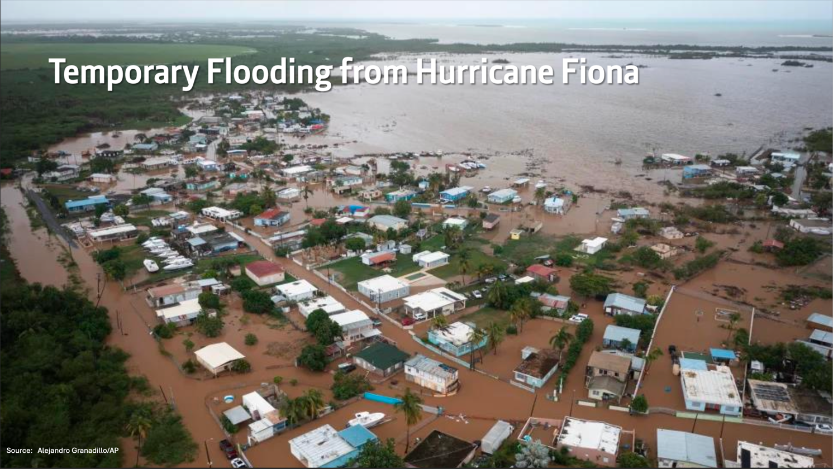

Figure : The flooding from the Hurricane Fiona.

Rising Sea Levels: Rising sea levels pose a critical risk to Puerto Rico’s coastal areas, where a significant portion of the population resides. This rise contributes to more frequent coastal flooding, coastal erosion, and the salinization of freshwater resources [3]. Coastal infrastructure, such as roads, bridges, and homes, faces increasing damage, and the tourism industry, a vital component of Puerto Rico’s economy, is also at risk. Additionally, saltwater intrusion threatens agricultural lands and freshwater supplies, further affecting food security and public health. The social implications are equally profound, as communities living in low-lying areas may face displacement due to the increased risk of flooding and erosion. Addressing these concerns requires comprehensive coastal management plans, the implementation of climate-resilient infrastructure, and community engagement to develop effective adaptation strategies.

Increased Flooding: Beyond the coastal regions, Puerto Rico is experiencing more intense and frequent rainfall, leading to severe inland flooding. These floods disrupt daily life, damage infrastructure, and destroy homes, especially in areas already prone to landslides [4]. The disruption to transportation systems, including road and bridge washouts, hampers emergency response and affects economic activities, as it limits access to essential services and work. Flooding also presents public health risks, as it can lead to the contamination of water supplies, increased incidence of waterborne diseases, and heightened mental health stresses. The frequency and severity of these events complicate disaster preparedness and recovery efforts. Effective flood management and early warning systems are therefore crucial to reduce the associated risks and impacts.

Environmental Injustice: The impacts of climate change are not evenly distributed across Puerto Rico's population. Vulnerable communities, particularly those in low-income and marginalized areas, bear the disproportionate burden of climate-related challenges [5]. Limited access to resources, lack of adequate housing, and restricted access to information hinder these communities' ability to prepare for and recover from extreme weather events. For example, neighborhoods with less robust infrastructure are more susceptible to flooding and wind damage, resulting in longer recovery times and increased economic hardship. This inequity highlights the need for an approach that prioritizes social justice, ensuring that the most vulnerable populations are included in climate resilience planning and receive the support necessary to adapt and thrive in the face of these challenges.

Economic and Social Impacts: Climate-related disasters significantly affect Puerto Rico's economy and social structure. Recovery efforts demand substantial financial resources, leading to a strain on public and private sectors. The recurring costs associated with disaster recovery, infrastructure repair, and property loss continue to grow, impeding the island’s economic progress [6]. Business disruptions due to hurricanes, flooding, and power outages contribute to rising unemployment rates and exacerbating social inequalities. Additionally, the increased poverty levels place further demands on social services, stretching government resources thin and limiting the island's ability to invest in future growth and development. These interconnected economic and social impacts emphasize the necessity of adopting comprehensive, long-term strategies that integrate climate resilience into economic planning.

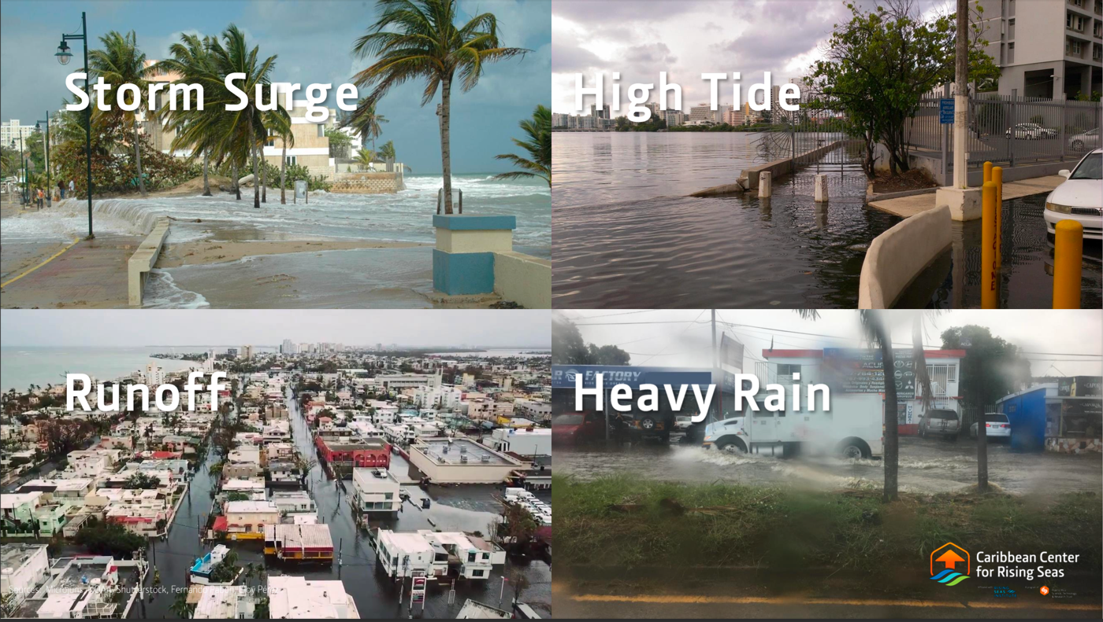

Figure : The different ways the disruption of a community can happen.

The challenges outlined above underscore the complexity of Puerto Rico's climate-related problems. They highlight the need for data-driven approaches to inform policymaking, infrastructure design, and community engagement. Addressing these issues requires real-time monitoring, predictive modeling, and equitable decision-making to foster resilience and sustainability. The success of this endeavor depends on collaboration among stakeholders, including government agencies, non-profit organizations, academic institutions, and the communities themselves.

## Research

The research undertaken for this project aimed to address the challenges posed by Puerto Rico's vulnerability to natural hazards and the subsequent risks to its critical infrastructure. The goal was to compile and analyze relevant data to develop a dashboard that prioritizes infrastructure investments based on risk exposure and resilience needs. This summary synthesizes insights gathered from reports, academic studies, and case analyses.[2]

**1. Overview of Vulnerabilities:**

A new analysis by the Union of Concerned Scientists (UCS) highlights that rising sea levels threaten over 325 critical infrastructure sites in Puerto Rico. These include essential facilities such as schools, hospitals, and water treatment plants, which are at risk due to coastal erosion and increased flooding. UCS emphasizes the need for urgent planning and investments to mitigate these risks and ensure infrastructure resilience against climate-related events​.

The Media Engagement Group discusses the broader impacts of climate change on Puerto Rico, emphasizing hurricanes, flooding, and increased temperatures. These changes strain public systems, exacerbate socioeconomic inequalities, and intensify the need for adaptive strategies to protect vulnerable communities​. This aligns with findings from the FEMA Infrastructure Interdependency Assessment, which underscores the interconnections between various infrastructure systems—such as electricity, water, transportation, and communications—and the cascading effects of their failures​.

**2. Data Sources and Literature Review**

This research draws upon various data sources and literature to assess Puerto Rico’s infrastructure vulnerabilities and guide the development of an interactive dashboard. Key references include the Union of Concerned Scientists’ (UCS) analysis, which highlights the rising sea levels threatening over 325 critical facilities across Puerto Rico (UCS, 2024)​. The Media Engagement Group provides an in-depth examination of climate change's broader impacts, including rising temperatures, flooding, and hurricanes, which exacerbate existing socioeconomic disparities and strain public infrastructure (Media Engagement Group, 2024)​. Additionally, the FEMA Infrastructure Interdependency Assessment served as a cornerstone for evaluating lifeline sector dependencies such as energy, water, transportation, and communications (FEMA, 2018)​.

The analysis leverages tools such as the Puerto Rico Infrastructure Interdependency Assessment (PRIIA), which integrates geodatabases, GIS tools, and relational tables to visualize infrastructure dependencies. FEMA’s approach to system and asset-level analyses informed this study, enabling a “system of systems” perspective that captures interconnections and cascading risks (FEMA, 2018)​.

**3. Modeling and Risk Assessment**

Modeling and risk assessment techniques were pivotal in quantifying Puerto Rico’s exposure to climate-induced hazards. Using FEMA’s methodology, a combination of top-down and bottom-up approaches was applied to assess vulnerabilities across critical sectors, including energy, water, and transportation. The PRIIA toolset provided advanced dependency visualization for first- and second-order risks, enabling policymakers to simulate cascading effects and predict impacts on community resilience (FEMA, 2018)​.

Risk metrics incorporated in this study include exposure to rising sea levels, storm surge, and wind damage. Hurricanes Maria and Fiona served as critical case studies, demonstrating the role of interconnected systems in amplifying the disruption of essential services. The modeling process revealed significant dependencies between infrastructure sectors, such as how water systems rely on power generation and communication networks to maintain operational stability (FEMA, 2018)​.

4. Socio-Economic Impact of Climate Change

The socio-economic consequences of climate change in Puerto Rico are profound. Rising sea levels threaten not only infrastructure but also displace communities, disrupt economies, and intensify inequalities. UCS reports that by 2045, over 25% of Puerto Rico’s coastal areas could face permanent inundation without intervention, jeopardizing economic hubs and public services (UCS, 2024)​.

The Media Engagement Group highlights the disproportionate burden on vulnerable communities, who often lack access to resources for adaptation. Climate events, such as hurricanes, result in extended power outages, disrupt supply chains, and lead to job losses in critical sectors like agriculture and manufacturing (Media Engagement Group, 2024)​. Additionally, FEMA’s findings underline the cascading economic impacts caused by infrastructure disruptions, particularly in healthcare, food distribution, and transportation sectors​.

**5. Policy Recommendations and Future Directions**

This research underscores the need for a multi-faceted policy approach to enhance Puerto Rico’s infrastructure resilience. Key recommendations include:

* Real-Time Hazard Monitoring: Implementing advanced monitoring systems to provide actionable data on flooding, storm surge, and other hazards (FEMA, 2018)​.
* Investment in Adaptive Infrastructure: Prioritizing resilient designs for public facilities in flood-prone areas to withstand future climate impacts (UCS, 2024)​.
* Community Engagement: Expanding public awareness programs to empower communities in disaster preparedness and resilience planning (Media Engagement Group, 2024)​.
* Technology-Driven Decision Making: Leveraging machine learning and AI for multi-criteria risk prioritization, ensuring efficient allocation of resources based on vulnerability and criticality (FEMA, 2018)​.

Future research should focus on integrating economic cost-benefit analyses and incorporating ecosystem-based solutions to maximize long-term benefits.

**6. Concluding Remarks**

The research presented highlights the urgent need for proactive, data-driven strategies to address Puerto Rico’s climate vulnerabilities. By consolidating diverse data sources, applying robust modeling techniques, and addressing socio-economic disparities, this study lays the groundwork for a scalable, actionable solution. The insights derived will directly inform the development of the proposed interactive dashboard, empowering policymakers to make informed, strategic investments that enhance infrastructure resilience and safeguard public welfare. This initiative is a critical step toward building a more sustainable and equitable future for Puerto Rico.

## Solution Space

Our solution focuses on developing an interactive data dashboard to support Puerto Rico's policymakers in making informed, data-driven decisions for infrastructure investment and resilience planning. The dashboard will rank public assets—such as hospitals, schools, water treatment plants, and emergency facilities—based on their exposure to natural hazards, including hurricanes, flooding, and rising sea levels.

The system derives value by aggregating and analyzing critical data from multiple sources, such as hazard exposure maps, socio-economic indicators, and infrastructure dependencies. Using a rule-based ranking framework and risk assessment methodologies, the dashboard will prioritize public assets for investment. The framework incorporates hazard severity, infrastructure criticality, and vulnerability to create a clear, actionable ranking system for decision-makers.

The dashboard will feature a user-friendly interface, ensuring accessibility for policymakers and urban planners. It will allow users to visualize risks, compare infrastructure priorities, and generate reports to guide resource allocation and disaster resilience strategies. By providing an organized and systematic approach to resilience planning, this tool is designed to reduce the risks of infrastructure failure, enhance disaster preparedness, and improve community safety and economic stability.

## Project Objectives

The primary objective of this project is to develop a comprehensive understanding of how natural hazards—such as hurricanes, flooding, and rising sea levels—impact critical infrastructure in Puerto Rico. Through this process, the team aims to gain insights into the factors driving infrastructure vulnerability and the interdependencies between key sectors. The culmination of this effort will be the creation of an interactive data dashboard that provides a prioritized list of public assets based on their risk exposure, offering policymakers and planners a practical tool for resource allocation and resilience planning. By integrating data from diverse sources and employing a systematic ranking framework, the project seeks to provide actionable solutions for disaster preparedness and long-term sustainability. Ultimately, the team hopes this project will add value by empowering decision-makers to safeguard vulnerable communities, optimize investments, and enhance overall infrastructure resilience, contributing to Puerto Rico’s economic stability and public safety.

## Primary User Stories

As a policymaker, I want an interactive dashboard that consolidates data from multiple sources and provides a prioritized ranking of public infrastructure assets based on their risk exposure to natural hazards. This will allow me to allocate limited resources strategically, protect vulnerable communities, and enhance disaster preparedness and resilience planning.

## Product Vision

### Scenario #1

Policymakers responsible for infrastructure investment and disaster preparedness in Puerto Rico can use the interactive dashboard to allocate limited resources effectively. The dashboard consolidates hazard data, socio-economic factors, and infrastructure dependencies to rank public assets based on their risk and criticality. Unlike fragmented data systems or subjective prioritization methods, this evidence-based tool provides a transparent framework for making informed decisions, optimizing investments, and reducing infrastructure risks.

### Scenario #2

Urban planners and disaster response agencies can leverage the dashboard to prepare for future climate-related events by identifying the most vulnerable public assets and developing targeted mitigation strategies. With its intuitive interface and detailed visualizations, the tool highlights interdependencies between infrastructure sectors, allowing planners to address weak points and minimize cascading failures during emergencies. Unlike traditional static reports, this dynamic and interactive platform enables users to adapt to evolving conditions, though it depends on reliable data inputs and may require training for effective use.

# Datasets

## Overview

**FEMA**

The FEMA datasets offer a comprehensive view of the National Risk Index (NRI), which measures and ranks disaster risk across different locations based on factors like expected annual loss, social vulnerability, and community resilience. These datasets include a cleaned version of the NRI data, descriptions and classifications of various hazards (such as hurricanes, floods, and earthquakes), and county-specific risk scores for Puerto Rico. The NRI information is crucial for evaluating region-specific disaster risks, identifying which hazards are most likely to impact a community, and understanding how social and infrastructure factors may influence resilience. This data can guide decision-makers in prioritizing disaster preparedness and response strategies.

**Internal Data – (PRSTRT)**

The Internal datasets are focused on municipality-specific and infrastructure-level data, particularly in relation to sea level rise (SLR) impacts. The municipality dataset provides SLR projections for various regions, detailing potential impacts on local populations, infrastructure, and key areas of concern. The infrastructure dataset goes deeper, cataloging specific types of infrastructure (e.g., transportation hubs, hospitals) and assessing their condition, geographic location, and risk levels due to environmental threats like rising sea levels. This information is critical for local planning and resource allocation, as it highlights vulnerable infrastructure points and enables targeted mitigation strategies for areas most at risk of SLR-related damage.

**School Shelters**

The dataset provides comprehensive information about school facilities in Puerto Rico designated as shelters, detailing their geographic locations, categorization, and capacities under both normal and emergency conditions. It includes 416 entries, with each facility identified by name and location using latitude and longitude coordinates, enabling spatial analysis or mapping. Facilities are categorized in the "PRI / ALT / TEMP / EMERG" column, indicating their type or priority for use during emergencies. Shelter capacities vary widely, with normal capacities ranging from 7 to 807 and emergency capacities increasing to a range of 14 to 1614, reflecting the adaptive response to disasters. This variation highlights the diversity of shelters, from small community-based facilities to large-scale centers. The dataset's geographic coverage largely aligns with Puerto Rico’s location, though some outliers in longitude may require verification. This data is instrumental in analyzing shelter distribution, identifying gaps in coverage, and guiding strategic disaster response planning. It also supports potential applications like mapping shelter networks and assessing preparedness through capacity and categorization insights

**ArcGIS**

ArcGIS is a geospatial software that provides a range of geographic datasets specific to the Puerto Rican landscape, it is one of the project's most important data sources. We can map and examine spatial layers pertaining to flood zones, land use, and exposure to natural disasters thanks to the high-resolution geodatabases made available by the ArcGIS platform. Our data pipeline filters, transforms, and integrates every dataset to guarantee accuracy and applicability to the impact assessment of coastal infrastructure.  
  
The following ArcGIS layers were used in this project:

* Topography and Elevation Data: This dataset is essential for comprehending elevation gradients throughout coastal regions and helps us forecast which areas are most likely to be inundated as a result of sea level rise.
* Flood Zone and Risk Information: This information, which is taken from FEMA flood maps and incorporated into ArcGIS layers, identifies high-risk areas for infrastructure planning by highlighting regions with different levels of flood danger. Layers mapping vital infrastructure, such as schools, hospitals, airports, and power substations, are included in the category of infrastructure layers. We can evaluate how sea level rise will affect vital public services thanks to this data.
* Environmental Hazard Layers: Information about natural disasters such as hurricanes and tsunamis adds another level of risk exposure, which aids in developing a thorough risk profile for coastal infrastructure.

These ArcGIS data layers are all pre-processed to eliminate redundant information and standardized to fit the spatial scope of our investigation. The filtered datasets are then converted according to the presentation structure of our dashboard, improving end users' ability to use spatial information.

## Field Descriptions

**FEMA** (National Risk Index Hazard Information) **:**

1. OBJECTID (Type: Integer) – A unique identifier for each record in the dataset.
2. Shape (Type: Geometry) – Defines the spatial representation of each feature, storing geographic data.
3. Shape_Length (Type: Double) – Represents the perimeter length of the geographic feature.
4. Shape_Area (Type: Double) – Represents the area size of the geographic feature.
5. STATE (Type: String) – The name of the state where the feature is located.
6. OID_ (Type: Integer) – A unique identifier for each hazard record in the dataset.
7. Hazard (Type: String) – The type of hazard being analysed (e.g., Avalanche, Coastal Flooding).
8. Prefix (Type: String) – The abbreviation used to represent the hazard type.
9. Service (Type: String) – The general category or description of the hazard service.
10. Start (Type: Integer) – The start year for the period over which the hazard data was recorded.
11. End_ (Type: Float) – The end year for the hazard data record. This may include decimal values if partial years are represented.
12. Total Years (Type: Integer) – The total number of years covered in the hazard data record.
13. Frequency Model (Type: String) – Indicates the model used to measure hazard frequency (e.g., "Annualized Frequency" or "Probability").
14. EAL_Building (Type: Integer) – Expected Annual Loss (EAL) attributed to buildings due to the hazard.
15. EAL_Population (Type: Integer) – Expected Annual Loss (EAL) impacting the population due to the hazard.
16. EAL_Agriculture (Type: Integer) – Expected Annual Loss (EAL) impacting agriculture due to the hazard.
17. PeriodOfRecord (Type: String) – The period during which data for the hazard was recorded, including the total years in parentheses.
18. NRI_VER (Type: String) – The version of the National Risk Index associated with the dataset (e.g., "March 2023").

**Internal Datasets (PRSTRT):**

The Internal datasets contain the Public Infrastructure Data Points, Aggregate Economic Loss Results and County Level based Economic Impact Results.

1. Objectid (Type: Integer) – Unique identifier for each infrastructure feature in the dataset.
2. Level (Type: String) – Specifies the flood level (e.g., "10 ft") for which the infrastructure is mapped.
3. Layer_name (Type: String) – Indicates the type of infrastructure, such as "Airport" or "Schools."
4. x (Type: Float) – X-coordinate representing the longitude of the infrastructure point.
5. y (Type: Float) – Y-coordinate representing the latitude of the infrastructure point.
6. Sea Level Rise Scenario (Type: String) – Indicates the projected sea level rise scenario used in the analysis.
7. Year (Type: Integer) – The year for which the economic impact of sea level rise is projected.
8. Storm Return Period (Type: String) – Defines the frequency of storms (e.g., "5-year" or "50-year") used to assess economic loss.
9. Aggregate Economic Loss (Type: Integer) – The total projected economic loss (in dollars) from sea level rise and associated storms for each scenario.
10. Municipality (Type: String) – The name of the municipality where the economic impact is assessed.
11. Street (Type: String) – The street name where infrastructure is located.
12. City (Type: String) – The city within Aguada where the infrastructure is situated.
13. Zip Code (Type: Integer) – The postal code associated with the infrastructure location.
14. County (Type: String) – The county where the infrastructure is located.
15. State (Type: String) – The state (PR for Puerto Rico) where the infrastructure is located.
16. Latitude (Type: Float) – The geographic latitude of the infrastructure location.
17. Longitude (Type: Float) – The geographic longitude of the infrastructure location.
18. Area (Type: Float) – The size of the infrastructure area in square meters.
19. FEMA Flood Zone (Type: String) – Indicates the FEMA flood zone designation for the infrastructure location.
20. Mean Structure Expected Loss from 25-year storm in 2110 using NOAA 2022 1.5 meter (Type: Integer) – Estimated mean loss for structures from a 25-year storm projected in 2110 with a 1.5-meter sea level rise scenario.

School Shelters Dataset:

1. Facility Name (Type: string): Names of school facilities designated as shelters, used for identification and analysis.
2. Latitude (Type: float): Geographic latitude coordinates of shelters, essential for spatial mapping.
3. Longitude (Type: float): Geographic longitude coordinates of shelters, paired with latitude for precise location.
4. Shelter Type (Type: string): Categorization of shelters (e.g., Primary, Temporary, Emergency) based on their usage.
5. Refugee Capacity (Type: integer): Standard capacity indicating the number of people each shelter can house normally.
6. Emergency Refugee Capacity (Type: integer): Maximum capacity shelters can accommodate during emergencies.

## Data Context

The objective of this project is to assess the impact of sea level rise on public infrastructure across Puerto Rico, particularly in coastal regions. To achieve this, we integrate data from multiple sources, each providing unique insights. The following datasets contribute essential context for understanding the vulnerabilities of infrastructure and formulating targeted strategies to mitigate future risks.

FEMA (National Risk Index - NRI):

The FEMA dataset provides a broad, national perspective on disaster risk with localized data for Puerto Rico. It is designed to quantify the potential impact of hazards such as floods, hurricanes, and earthquakes. The inclusion of Expected Annual Loss (EAL) metrics for buildings, populations, and agriculture adds a comprehensive risk evaluation layer. The social vulnerability and resilience measures included in the data provide additional insights into the ability of communities to withstand and recover from disasters. Contextually, this dataset is invaluable for identifying high-risk areas and supporting broad-scale policy and planning decisions, especially when layered with local-level data.

Internal Data (PRSTRT):

This dataset is tailored for municipality-specific insights, focusing on the local impacts of sea-level rise (SLR) and associated flooding. By cataloging infrastructure types and their geographic distribution, it allows for a granular analysis of vulnerabilities and dependencies. The inclusion of economic loss projections and flood scenarios underscores its relevance to financial and resource allocation planning. This dataset provides critical context for understanding how environmental changes, such as rising sea levels, directly impact infrastructure and communities at a micro level, enabling highly targeted interventions.

Shelters Data:

The shelters dataset focuses on disaster response infrastructure, mapping the geographic distribution, categorization, and capacity of school facilities designated as shelters. It provides both normal and emergency capacity data, which reflects the adaptive strategies employed during disasters. By including categorization fields such as "Primary" and "Emergency," this dataset offers insight into prioritization and shelter utilization strategies. Contextually, it highlights both strengths and potential gaps in Puerto Rico’s shelter network, serving as a foundation for analyzing accessibility and preparedness.

ArcGIS Layers:

The ArcGIS layers offer a geospatial perspective on hazard exposure and infrastructure vulnerability. By integrating topography, flood zones, and environmental hazards, these layers allow for a spatially accurate understanding of risks. The elevation and flood zone data are particularly critical for modeling sea-level rise impacts, while infrastructure and environmental hazard layers help visualize interdependencies. This geospatial context ensures that decisions are informed by both the physical landscape and the distribution of critical assets.

Integration and Relevance

The integration of these datasets allows for a multi-layered analysis of disaster risks, infrastructure vulnerabilities, and response capabilities. The FEMA dataset provides a high-level national overview, while the internal data and shelters dataset bring localized, infrastructure-specific insights. ArcGIS layers tie everything together with spatial precision, enabling dynamic visualizations and scenario modeling. Together, these datasets form a comprehensive framework for understanding disaster resilience in Puerto Rico, ensuring that decisions are grounded in both macro- and micro-level contexts.

This detailed context ensures the datasets are used appropriately to guide strategic investments and disaster preparedness efforts, ultimately enhancing resilience and protecting vulnerable communities.

## Data Conditioning

Data conditioning in this project focused on improving the quality of the data and make sure that every dataset made a meaningful contribution to the comprehension of how sea level rise affects Puerto Rican public infrastructure. In addition to technical cleaning, the conditioning process evaluated the systems that supported the collection and upkeep of each dataset, as well as its use and analytical value.

The FEMA National Risk Index (NRI) dataset was conditioned to focus on Puerto Rico-specific hazard data. Irrelevant fields and redundant records were removed, and geographic identifiers such as county names were standardized. Temporal data was converted into consistent formats, and hazard-specific metrics, including flood and hurricane data, were integrated with expected annual loss (EAL) values for buildings, populations, and agriculture. Additionally, county-level data was aggregated to align with the project's objectives, enabling infrastructure prioritization based on regional risks.

The Internal Data (PRSTRT) underwent rigorous validation of geographic coordinates to ensure accuracy within Puerto Rico’s boundaries. Flood levels, sea level rise scenarios, and economic loss metrics were normalized to facilitate cross-comparison between data points. Missing or null values for infrastructure attributes were addressed using interpolation or external references, ensuring completeness. Infrastructure types, such as schools and hospitals, were classified into consistent categories, enabling multi-criteria analysis of risks and vulnerabilities.

The Shelters Dataset was conditioned through geospatial cleaning, correcting anomalies in latitude and longitude to ensure accurate mapping of shelter locations. Discrepancies between normal and emergency shelter capacities were reconciled, and facility types (e.g., "Primary," "Emergency") were standardized into uniform labels. This preparation enabled a comprehensive understanding of shelter distribution, capacity, and categorization, ensuring the data accurately reflected Puerto Rico’s disaster response capabilities.

The ArcGIS Layers were pre-processed to filter relevant spatial data, including topography, flood zones, and critical infrastructure locations. All spatial datasets were standardized to use the same projection systems, ensuring compatibility and seamless integration. Environmental hazard layers, such as hurricane and tsunami data, were integrated with critical infrastructure data to assess interdependencies. Additionally, redundant spatial features and duplicate records were removed, optimizing the datasets for efficient use in geospatial analysis and dashboard visualization.

By conditioning each dataset to meet project requirements, this process ensured consistency, accuracy, and reliability, enabling their integration into the interactive dashboard and empowering stakeholders with actionable insights for informed decision-making.

## Data Quality Assessment

**FEMA Flood Zone Data**

* **Completeness**: High completeness; all major flood zones are covered for Puerto Rico, providing a comprehensive assessment of flood risks with prediction estimates provided till 2050.
* **Uniqueness**: Unique geographic features without duplication, as each flood zone is represented distinctly.
* **Accuracy**: As FEMA’s data is sporadically updated and validated by federal standards it is not a highly accurate data sources due to which it has been validation through data available in NOAA.
* **Atomicity**: With each flood zone classified independently, each data point represents a distinct hazard level.
* **Conformity**: Consistent with federal flood zone classifications, enabling integration with other standardized datasets.
* **Overall Quality**: Average quality; FEMA’s authoritative data supports reliable risk assessments for Puerto Rican infrastructure.

**ArcGIS Data**

* **Completeness**: Comprehensive; ArcGIS provides an extensive range of spatial layers relevant to Puerto Rico’s topography, infrastructure, and hazards.
* **Uniqueness**: Maintains uniqueness with precise spatial referencing, avoiding overlaps or redundancies.
* **Accuracy**: High spatial accuracy, essential for mapping and visual analysis of risk exposure.
* **Atomicity**: High atomicity, with each feature (e.g., infrastructure, elevation) individually represented for detailed analysis.
* **Conformity**: Consistent with GIS standards, with uniform formatting and projections across layers.
* **Overall Quality**: Excellent quality; ArcGIS data is well-suited for visualizing and analysing the geographic distribution of infrastructure vulnerabilities.

**Arkly Dataset**

* **Completeness**: Mostly complete, though some demographic fields have minor gaps that could impact socio-economic analysis.
* **Uniqueness**: Unique community attributes are represented without redundancy, providing a clear socio-economic profile.
* **Accuracy**: Generally accurate, sourced from a blend of reliable public and private records; minor inconsistencies may require verification.
* **Atomicity**: High atomicity, with each socio-economic factor represented independently for focused analysis.
* **Conformity**: Conforms to demographic and economic standards, ensuring compatibility across related datasets.
* **Overall Quality**: Good quality; Arkly data offers valuable socio-economic context despite minor completeness issues.

**Infrastructure Data (Internal Dataset)**

* **Completeness**: High completeness, covering critical infrastructure details like age, condition, and resilience measures specific to Puerto Rico.
* **Uniqueness**: Maintains uniqueness, with each infrastructure asset distinctly represented, avoiding duplication.
* **Accuracy**: High accuracy, particularly useful due to local agency verification; some entries may need supplemental detail.
* **Atomicity**: Strong atomicity, with individual attributes for each asset allowing precise vulnerability assessments.
* **Conformity**: Conforms to local data standards, ensuring seamless integration with related datasets.
* **Overall Quality**: Excellent quality; the internal dataset is reliable and essential for specific infrastructure insights tailored to Puerto Rico.

**School Shelters Data**

* Completeness: The dataset is largely complete with 416 entries, though minor gaps exist in geographic coordinates and categorization fields.
* Uniqueness: Facility names and geographic coordinates ensure unique representation, with minimal risk of duplication.
* Accuracy: Most data aligns with Puerto Rico’s locations, but some longitude values and capacity data require validation.
* Atomicity: Fields are well-structured, with distinct information for capacity, categorization, and location.
* Conformity: Data conforms to standard formats, though shelter categorization could benefit from consistent naming conventions.
* Overall Quality: High-quality dataset with minor issues; resolving outliers, missing values, and standardization will enhance reliability.

## Other Data Sources

Several additional data sources provided valuable context and enhanced the robustness of the project’s infrastructure and risk assessment. Each of these sources was selected for its relevance to Puerto Rico’s unique geographic and socio-economic conditions.

**NOAA (National Oceanic and Atmospheric Administration)**  
NOAA’s climate data was used to model sea level rise projections and assess future environmental conditions impacting Puerto Rico. This source provided reliable scientific insights on climate trends, enhancing our understanding of potential long-term impacts on infrastructure [5].

**Community Resilience Estimates (CRE) - U.S. Census Bureau**  
The CRE documentation and detailed tables offer data on Puerto Rico’s community resilience, assessing socio-economic factors that influence a community’s ability to respond to climate risks. This information was crucial for examining the social dimensions of infrastructure vulnerability [6].

**Emergency Management Hub (EM Hub) - U.S. Census Bureau**

The EM Hub provides emergency management data, including disaster preparedness and response resources. This source helped contextualize infrastructure needs in high-risk areas, supporting targeted resilience planning for Puerto Rico’s coastal communities [7].

**Available APIs - U.S. Census Bureau**  
The Census Bureau’s APIs enabled access to diverse datasets, including CRE data, supporting dynamic integration into the project’s analysis framework. This facilitated efficient data retrieval and streamlined updates from national databases [8].

**Community Resilience Estimates API for Puerto Rico**  
The CRE API provides direct access to Puerto Rico’s resilience data, focusing on demographic factors related to community resilience. This API allowed seamless integration of resilience data into our analysis, enhancing the socio-economic assessment of infrastructure risks [9].

## Storage Medium

To guarantee convenient access and processing effectiveness, the datasets for this project are kept locally because of its size and no need for scalability. High-speed data processing is made possible by this local storage media, which lowers latency and speeds up data conditioning, cleaning, and analysis. The datasets are also copied to a private GitHub repository, which serves as a backup and version control system that permits group updates while maintaining past modifications. GitHub is perfect for project documentation and collaboration since it allows for the organized maintenance of multiple dataset versions.

## Storage Security

Local storage is secured with user authentication and access control to guarantee data security, restricting dataset accessibility to project participants who are approved. Because the GitHub repository is private, it is protected by authentication mechanisms like token-based access or SSH keys, which offer regulated repository access. Data integrity and security are maintained by managing both storage media with frequent updates and backup plans to guard against data loss and illegal access.

## Storage Costs

The local storage incurs minimal costs, as it relies on existing workstation infrastructure without additional expenses. The private GitHub repository is currently hosted under a free-tier plan, which covers the project’s storage needs without incurring fees. If the project data grows significantly or requires enhanced GitHub features, additional storage or premium services may be considered, but for the current scope, storage costs are not applied to your project

# Dashboard Development and Data Integration

## Dashboard Design and Data Integration.

### Dashboard Structure

The interactive dashboard is designed to present critical information in a clear, intuitive format to support decision-making for infrastructure resilience and disaster preparedness in Puerto Rico. It consists of three main pages, each tailored to provide unique insights for different stakeholders, with a focus on infrastructure tier ratings, county-level demographic data, and shelter capacities.

**Page 1: Infrastructure Data and Tier Ratings**

This page serves as the foundation of the dashboard, showcasing infrastructure tier ratings derived from risk analysis. The tier ratings prioritize public assets—such as hospitals, schools, and law enforcement facilities—based on their exposure to flooding and other natural hazards, as well as their resilience priorities.

A key feature of this page is the **ArcGIS-embedded interactive map**, allowing users to explore the spatial distribution of public infrastructure. The map integrates high-resolution data layers, including flood zones, critical infrastructure locations, and elevation gradients, to provide a spatial perspective on risk exposure. This map also supports zoom and filter functionalities, enabling users to focus on specific regions or asset types.

**Key Components:**

* **Tier Rating Visualization**: A clear, color-coded representation of infrastructure rankings, highlighting assets with the highest priority for intervention.
* **ArcGIS Embedded Map for Spatial Exploration**: An interactive tool to visualize geographic and hazard data, integrating infrastructure locations with flood zone overlays.
* **Comprehensive Infrastructure Data**: Detailed tables and charts displaying infrastructure attributes such as condition, risk level, and resilience metrics.

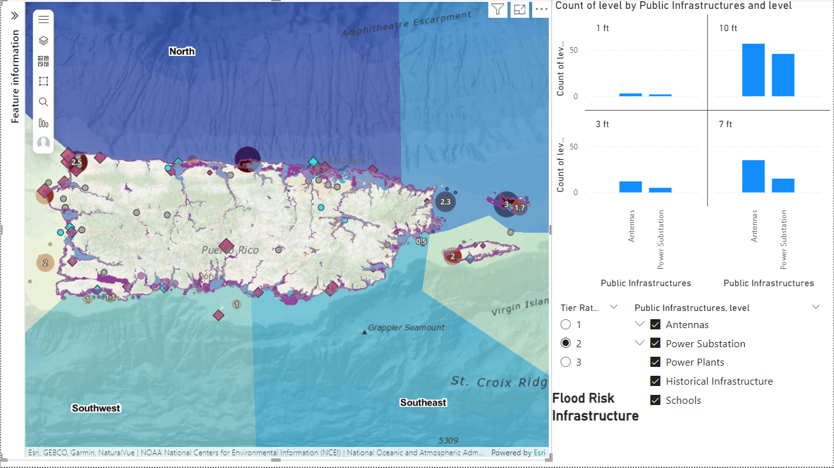

Figure 3: Dashboard Page 1; Infrastructure Data and Tier Ratings

**Page 2: County-Level Data with Demographics**

This page focuses on providing granular insights into county-level data, including key demographic statistics such as population size, area, and social vulnerability indicators. The page is designed to support stakeholders in assessing vulnerabilities and resource allocation across different counties.

A set of **filters** enables users to narrow their analysis by population thresholds, area size, and other demographic parameters. Comparative visualizations, such as bar charts and heat maps, allow stakeholders to identify counties with higher vulnerability or unique needs, ensuring targeted policy and investment strategies.

**Key Components:**

* **County-Level Demographics Dashboard**: Displays population size, density, and socio-economic factors such as income levels and social vulnerability indices for each county.
* **Filters for Population and Area Metrics**: Dynamic filtering options for refining insights, such as highlighting counties with large populations or smaller land areas.
* **Visualizations for Comparative Analysis**: Tools like heat maps and graphs to compare demographic data across counties, providing a clear picture of relative vulnerabilities.

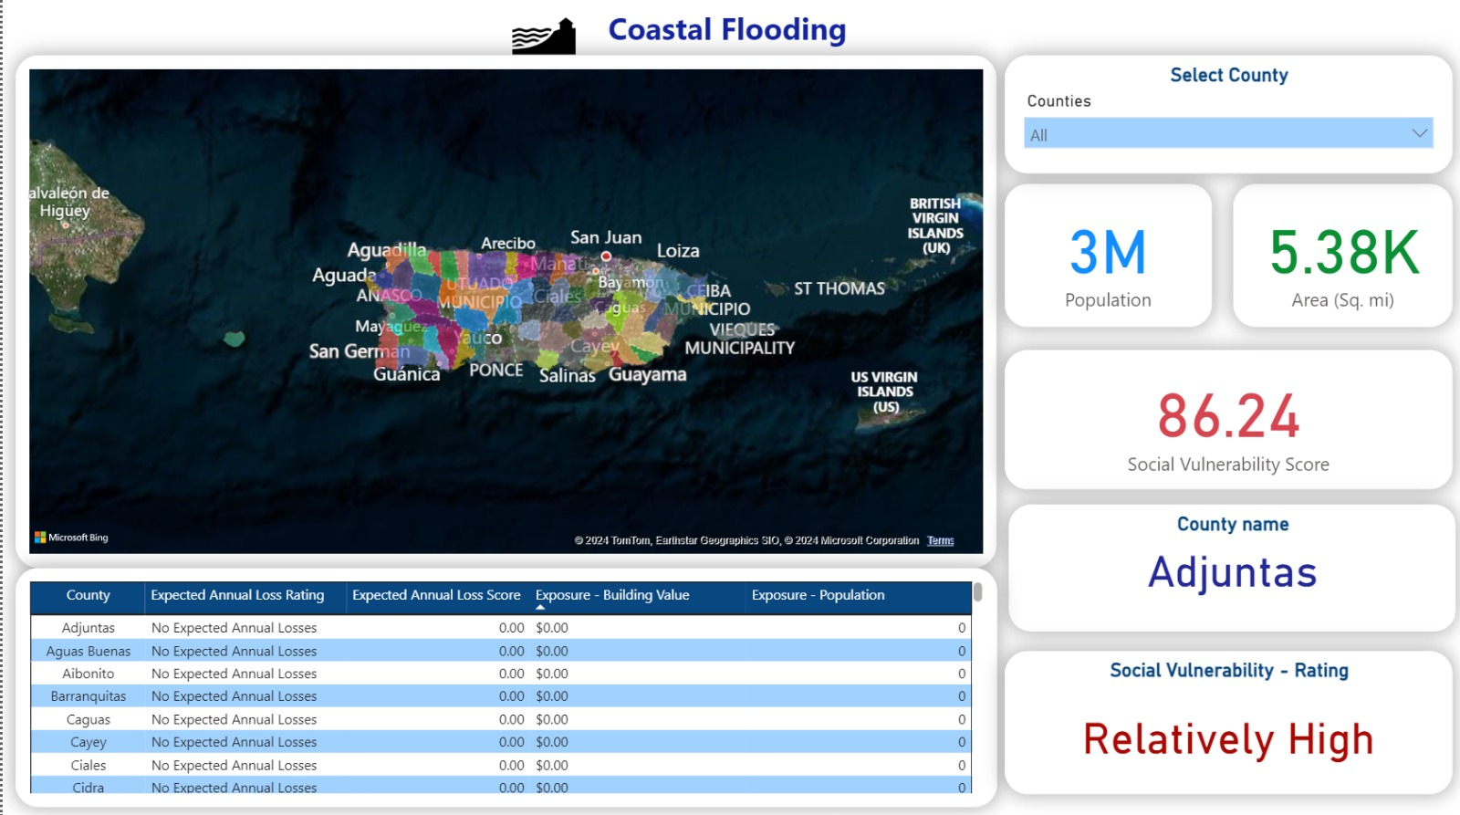

Figure 4: Dashboard Page 2; County – Level Data with Demographics

**Page 3: Shelter Data in Puerto Rico**

The third page focuses on shelter-related data, providing critical insights into the geographic distribution and capacity of shelters across Puerto Rico. This page is particularly valuable for disaster response teams and planners tasked with ensuring adequate shelter coverage during emergencies.

The **shelter data overview** section summarizes the capacities and locations of shelters, categorized by their usage type (e.g., primary, temporary, emergency). The page also incorporates visualizations and maps to display regional shelter distribution, identifying areas with insufficient shelter capacity or geographic gaps in coverage.

**Key Components:**

* **Shelter Data Overview**: Tabular and visual summaries of shelter capacities, including both normal and emergency accommodation numbers.
* **Shelter Locations and Capacities**: Interactive maps and charts illustrating the geographic locations of shelters alongside their categorized capacities.
* **Regional Distribution Insights**: Analysis of shelter availability and gaps in coverage, helping users identify regions with insufficient disaster preparedness infrastructure.

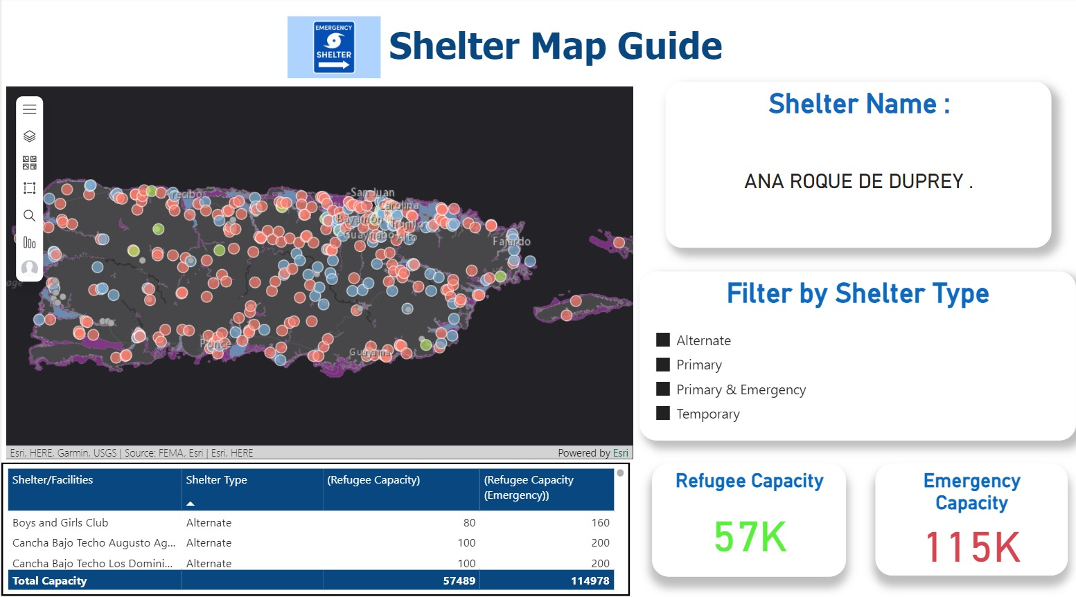

Figure 5: Dashboard Page 3; Shelter Data

### Data Integration Process

The data integration process for the project involved aggregating, preprocessing, and transforming data from various sources to ensure seamless compatibility for analysis and visualization. This process was essential to create a unified dataset that supports the analytical objectives and dashboard functionalities.

**Data Sources and Preprocessing**

The integration began with the aggregation of data from FEMA, internal datasets, and public resources. These datasets included information on infrastructure tier ratings, county-level demographics, and shelter capacities. Preprocessing ensured the accuracy, consistency, and compatibility of data across all sources.

Key steps in preprocessing included:

1. **Data Aggregation**: Datasets were merged to combine insights from multiple domains:
   * FEMA’s National Risk Index (NRI) data for hazard classifications and expected annual loss.
   * Infrastructure-level data from internal sources for tier rankings.
   * Demographic and population data for county-level analysis.
   * Shelter data for spatial analysis and capacity planning.
2. **Geospatial Data Formatting**: Spatial data, such as shelter locations and infrastructure points, was formatted for compatibility with ArcGIS. This included:
   * Standardizing coordinate systems (e.g., WGS84) for uniform mapping.
   * Resolving discrepancies in latitude and longitude data to ensure geographic accuracy.
   * Creating spatial features (e.g., polygons for flood zones, points for shelters) to support advanced geospatial queries.
3. **Handling Missing Values**: Missing or incomplete records were addressed to ensure the reliability of the analysis:
   * Imputation techniques were used for numeric fields, such as filling missing shelter capacities with median values from similar facilities.
   * External references, such as NOAA data, were used to validate and supplement infrastructure attributes when original datasets lacked detail.
   * Records with irrecoverable gaps were flagged for exclusion to maintain data integrity.
4. **Schema Consistency**: All datasets were normalized to ensure consistent field names, data types, and formats. For example:
   * Text fields, such as hazard descriptions and shelter categories, were standardized for uniform analysis.

**Data Transformation**

Once preprocessing was complete, data transformation tools were applied to prepare datasets for specific analytical and visualization tasks. Python libraries like pandas, as well as Power Query, were used for this purpose.

Key transformations included:

1. **Infrastructure Data Normalization**:
   * Infrastructure attributes, such as elevation, proximity to flood zones, and criticality, were normalized to comparable scales for tier ranking calculations.
   * Risk scores were computed using weighted formulas that combined hazard exposure and infrastructure importance metrics.
2. **Demographic Data Aggregation**:
   * County-level demographic data, including population size, area, and social vulnerability indices, were aggregated from raw census records and cleaned for dashboard integration.
   * Summarized statistics were generated for each county, enabling comparative visualizations and filtering in the dashboard.
3. **Shelter Data Preparation**:
   * Shelter locations were transformed into geospatial points and assigned unique identifiers for mapping.
   * Capacities (normal and emergency) were scaled for visualization, allowing stakeholders to easily interpret shelter readiness.
   * Categorization fields (e.g., primary, temporary, emergency) were standardized for consistent classification across the dataset.

**Final Integration for Dashboard Visualization**

After transformation, the datasets were integrated into a unified structure for dashboard development. Each dataset was aligned with its corresponding dashboard page:

* **Page 1 (Infrastructure Data)**: Infrastructure tier ratings and geospatial data were linked to the ArcGIS layers for interactive map functionality.
* **Page 2 (County-Level Data)**: Aggregated demographic data was formatted into tables and charts for comparative analysis.
* **Page 3 (Shelter Data)**: Shelter geospatial points, capacities, and classifications were visualized through maps and tabular summaries.

This structured data integration ensured that the dashboard could deliver accurate, interactive, and actionable insights to stakeholders.

## Analytical Insights and Exploration

### Analytical Approach

### The analytical approach for this project integrates multiple dimensions of risk assessment to develop actionable insights for infrastructure resilience, resource allocation, and emergency preparedness. By focusing on infrastructure tier analysis, county-level vulnerabilities, and shelter capacities, the analysis ensures that stakeholders are equipped with precise, data-driven recommendations to address Puerto Rico’s unique challenges.

Infrastructure Tier Analysis

The infrastructure tier ratings were developed by combining risk-based parameters, including elevation, proximity to flood zones, and the criticality of each infrastructure asset. Public assets such as hospitals, schools, and law enforcement facilities were evaluated against these parameters to determine their exposure to natural hazards and their importance in disaster response and recovery efforts.

Key factors considered in the analysis:

* **Elevation Data:** Lower-elevation infrastructure was assigned higher risk scores due to increased susceptibility to flooding and sea-level rise.
* **Proximity to Flood Zones:** Assets located within or near FEMA-designated flood zones were prioritized as high-risk due to potential inundation during extreme weather events.
* **Infrastructure Criticality:** Facilities critical for community resilience, such as hospitals and emergency services, were weighted more heavily in the tiering process to emphasize their importance in disaster response and recovery operations.

The results of this analysis are presented through tiered rankings, enabling stakeholders to quickly identify high-priority infrastructure for resilience investments. These tier ratings are visualized on the dashboard’s interactive ArcGIS map, allowing users to explore spatial patterns of vulnerability.

County-Level Insights

County-level analysis focused on identifying regions with heightened vulnerabilities by examining demographic and resource allocation metrics. Population density, land area, and socio-economic indicators were key variables used to determine disparities in vulnerability and resource distribution needs across Puerto Rico.

Steps in the analysis:

Population Density: Counties with higher population densities were flagged as areas requiring increased infrastructure resilience and resource allocation, as they face greater risks during disasters.

Socio-Economic Indicators: Social vulnerability indices, such as income levels and community resilience measures, were incorporated to assess the ability of populations to withstand and recover from disasters.

Resource Allocation Gaps: By comparing population density with existing infrastructure capacity, such as hospitals, shelters, and water treatment facilities, regions with potential resource gaps were identified.

This analysis ensures stakeholders can allocate resources equitably, prioritizing counties with the greatest needs. Visualization tools on the dashboard provide comparative insights, enabling targeted policy and investment strategies.

Shelter Capacity Analysis

Shelter capacity and distribution were analyzed to support emergency preparedness efforts. Using data on shelter locations, capacities, and categorization (e.g., primary, temporary, emergency), the analysis aimed to identify areas with insufficient shelter coverage and ensure equitable access to emergency housing during disasters.

Key elements of the analysis:

Capacity Assessments: Each shelter’s normal and emergency capacities were evaluated to determine their ability to accommodate populations during crises. Variations in capacity, ranging from small community-based shelters to large-scale facilities, were considered.

Geographic Distribution: Spatial analysis of shelter locations identified geographic gaps in coverage, ensuring that all regions, particularly high-risk coastal areas, have adequate access to shelters.

Categorization Insights: Shelters were categorized by their designated usage (e.g., primary, temporary, emergency) to understand their intended roles in disaster response. This helped assess the diversity and suitability of shelters in meeting varying disaster scenarios.

The findings from this analysis are displayed on a dedicated dashboard page, which includes interactive maps and visualizations to support emergency response planning. Policymakers can use these insights to address shelter shortages, optimize resource allocation, and improve disaster preparedness.

### Insights for Stakeholders

The integration of advanced analytical tools and comprehensive datasets has provided stakeholders with actionable insights, empowering data-driven decisions for disaster preparedness, resource allocation, and resilience planning. Each component of the dashboard addresses specific challenges faced by policymakers, urban planners, and emergency response teams, offering practical solutions through intuitive and visual data representations.

Spatial Analysis with ArcGIS and Power BI

The integration of ArcGIS with Power BI enabled an intuitive spatial analysis platform for stakeholders. The interactive maps allow users to explore geographic patterns of risk exposure and infrastructure vulnerability in Puerto Rico. This integration facilitated:

* Visual Risk Assessment: By overlaying infrastructure locations with flood zones, elevation data, and environmental hazard layers, stakeholders can quickly identify high-risk areas requiring immediate intervention.
* Spatial Prioritization: The mapping functionality enables planners to prioritize infrastructure investments based on spatial proximity to hazard zones, such as coastal flooding and hurricane-prone areas.
* Interactive Exploration: Users can filter map layers by criteria like infrastructure type, tier ratings, or region, ensuring they can focus on specific areas of concern without being overwhelmed by extraneous data.

This capability is particularly useful for decision-makers who require geospatial insights to plan for long-term resilience and disaster mitigation strategies.

Actionable Insights for Equitable Resource Distribution

The demographic analysis provided through county-level data equips stakeholders with actionable insights to allocate resources equitably across Puerto Rico. By examining metrics such as population density, area size, and socio-economic indicators, the dashboard helps policymakers:

* Identify Vulnerable Counties: Counties with higher social vulnerability indices or larger population densities are highlighted, ensuring that resource distribution prioritizes areas with the greatest needs.
* Optimize Resource Allocation: Comparative visualizations enable stakeholders to assess disparities in existing infrastructure and demographic pressures, facilitating targeted investments to bridge resource gaps.
* Support Strategic Planning: The granular analysis allows planners to balance resource allocation between urban centers and rural areas, ensuring comprehensive disaster preparedness across the island.

These insights guide equitable policy-making, addressing socio-economic disparities that may exacerbate the impacts of natural disasters on vulnerable populations.

Shelter Dashboard for Disaster Response and Planning

The shelter dashboard provides critical support for disaster response teams and planners by offering detailed insights into the distribution, capacity, and categorization of shelters across Puerto Rico. It ensures that emergency response strategies are informed by accurate, up-to-date data, enabling:

* Capacity Planning: Stakeholders can assess shelter readiness by examining normal and emergency capacities, ensuring that shelters can accommodate displaced populations effectively during disasters.
* Gap Identification: The geographic visualization of shelters highlights areas with insufficient coverage, allowing planners to address gaps in emergency housing infrastructure.
* Categorization Insights: Shelters categorized as primary, temporary, or emergency provide a clear understanding of their intended roles, helping disaster response teams allocate resources and prioritize shelter activation during crises.

By consolidating shelter-related data into an accessible, visual format, the dashboard ensures that Puerto Rico’s disaster response plans are well-prepared to handle varying levels of emergencies.

Empowering Stakeholders for Informed Decision-Making

Overall, the integration of ArcGIS with Power BI, coupled with detailed demographic and shelter analyses, equips stakeholders with a powerful toolset for addressing Puerto Rico’s resilience challenges. These insights:

* Enhance strategic planning by visualizing infrastructure vulnerabilities.
* Support equitable resource distribution through data-driven demographic analysis.
* Optimize emergency preparedness with actionable shelter insights.

By aligning these capabilities with stakeholder needs, the dashboard ensures that decision-makers are equipped to safeguard public infrastructure, protect vulnerable populations, and enhance Puerto Rico’s disaster resilience.

## Solution Implementation

### Dashboard Features

Interactive and Intuitive Design

The dashboard is built with a strong emphasis on user experience, ensuring that stakeholders can access, explore, and interpret critical data effortlessly. The design prioritizes interactivity and usability, making it an essential tool for policymakers, urban planners, and disaster response teams to derive actionable insights.

Key aspects of the design include:

Dynamic Filters:

* Users can apply customizable filters to focus on specific datasets or criteria. For example, stakeholders can filter infrastructure assets by risk tiers, shelter locations by capacity, or counties by population density.
* Filters for temporal data, such as expected sea-level rise scenarios or storm return periods, allow users to explore future projections and trends, enabling long-term planning.

Interactive Maps:

* ArcGIS Integration: High-resolution interactive maps provide a spatial representation of data, allowing users to visualize risks and vulnerabilities geographically. Users can zoom in and out, pan across regions, and toggle various map layers (e.g., flood zones, infrastructure locations, shelter distributions).
* Maps are layered with geospatial data, such as elevation gradients, flood risk zones, and infrastructure points, ensuring a detailed and intuitive exploration of geographic relationships.

Real-Time Data Visualizations:

* The dashboard features dynamic charts, graphs, and tables that update based on user interactions. For instance, selecting a county or infrastructure type on the map dynamically updates related visualizations to show tier ratings, demographics, or shelter capacities.
* Comparative visualizations, such as bar charts or heatmaps, allow users to assess disparities across counties or regions, providing clear insights for resource allocation.

Customizable Outputs:

* Users can generate tailored reports directly from the dashboard, summarizing selected data points, visualizations, and maps. These outputs can be used for presentations, policy briefs, or disaster response planning.

User-Friendly Navigation:

* The interface is structured to guide users intuitively through the three primary dashboard pages—Infrastructure Data and Tier Ratings, County-Level Data, and Shelter Analysis.
* Each page is equipped with tooltips and contextual explanations, ensuring users of all technical expertise levels can understand and utilize the dashboard effectively.

Responsive Design:

* The dashboard is designed to function seamlessly across devices, including desktops, tablets, and mobile platforms, ensuring accessibility for users in varied environments, such as field operations or policy meetings.

Scalable for Future Enhancements:

* Built with flexibility in mind, the dashboard can integrate additional datasets or new features in the future. This scalability ensures it remains relevant as data availability and stakeholder needs evolve.

By combining filters, interactive maps, and dynamic visualizations, the dashboard offers an intuitive platform for analyzing complex datasets and deriving insights. This interactivity not only simplifies data exploration but also empowers stakeholders to make informed decisions with confidence.

### Spatial and Analytical Tools

The dashboard integrates advanced spatial and analytical tools to provide stakeholders with a robust platform for exploring and interpreting complex datasets. These tools enable precise geospatial visualization and dynamic data analysis, ensuring that decision-makers can effectively prioritize resources and enhance disaster preparedness.

Embedded ArcGIS

The dashboard incorporates ArcGIS, a powerful geospatial platform, to facilitate interactive spatial exploration. This integration empowers stakeholders to visually assess risk exposure, infrastructure vulnerabilities, and shelter distributions across Puerto Rico.

Key features of the ArcGIS integration include:

* Interactive Mapping: Stakeholders can explore high-resolution maps with multiple layers, such as flood zones, elevation data, and critical infrastructure locations. These maps allow users to identify high-risk areas and assess their geographic relationships.
* Layer Toggle Options: Users can enable or disable specific map layers, such as sea-level rise scenarios or shelter distributions, to focus on areas of interest.
* Geospatial Queries: ArcGIS allows stakeholders to perform spatial queries, such as identifying all infrastructure assets within a designated flood zone or assessing the proximity of shelters to high-density populations.
* Custom Symbology: Infrastructure assets, flood zones, and other map elements are visually distinguished using custom symbology (e.g., color-coding for tier ratings or flood risk levels) to enhance interpretability.

By embedding ArcGIS within the dashboard, the tool provides a comprehensive spatial perspective that simplifies complex geographic data, making it accessible and actionable for stakeholders.

Power BI Features

Power BI enhances the dashboard’s analytical capabilities, offering dynamic interactivity and data drill-down features. By integrating custom measures and Data Analysis Expressions (DAX), the tool supports in-depth data exploration and analysis.

Key Power BI features include:

Custom Measures:

* Tailored calculations were implemented to generate key metrics, such as aggregate infrastructure risk scores, population density averages, and comparative shelter capacities. These measures ensure that users have access to meaningful insights without requiring manual computations.
* Examples include computing the weighted risk score for infrastructure tier rankings or calculating county-level socio-economic vulnerability indices.

Drill-Down Capabilities:

* Power BI’s drill-down functionality allows users to navigate through hierarchical data effortlessly. For instance:
  + Selecting a county on the demographics page reveals detailed statistics, such as population density, income levels, and infrastructure availability within that county.
  + Clicking on an infrastructure asset in the ArcGIS map dynamically updates associated data points, such as tier ratings, proximity to flood zones, and resilience priorities.
* This hierarchical navigation supports multi-level analysis, enabling users to transition smoothly between high-level overviews and granular details.

Dynamic Visualizations:

* Charts, graphs, and tables in Power BI are designed to respond dynamically to user inputs, such as filter selections or map interactions. This interactivity ensures that stakeholders can tailor the analysis to their specific needs.
* Comparative tools, such as side-by-side bar charts or heatmaps, allow stakeholders to evaluate disparities across regions or datasets effectively.

Integration and Usability

The combined use of ArcGIS for geospatial analysis and Power BI for data interactivity creates a seamless experience for stakeholders. Together, these tools ensure that users can:

* Visualize risks and vulnerabilities geographically.
* Analyze infrastructure and demographic data at varying levels of detail.
* Generate actionable insights through dynamic interactions with the dashboard.

This integration of spatial and analytical tools not only enhances the functionality of the dashboard but also ensures that stakeholders have access to precise, actionable, and visually engaging data for informed decision-making.

### Data Flow and Updates

The data flow and update mechanism for the dashboard is designed to ensure accuracy, scalability, and ease of maintenance. By implementing a robust data pipeline, the system minimizes manual intervention and supports periodic updates to keep the dashboard relevant and reliable for stakeholders.

Data Pipeline Design

The data pipeline integrates multiple sources, including FEMA datasets, internal data, and geospatial layers from ArcGIS. It was designed with scalability in mind, enabling seamless integration of additional datasets and new data points as they become available.

Key features of the data pipeline:

Data Aggregation:

* Data from various sources is collected and stored in a centralized repository.
* Standardized formats and schema ensure compatibility across diverse datasets, such as geospatial data, demographic records, and infrastructure information.

Data Transformation:

* Tools like Python (pandas) and Power Query are used to clean, normalize, and preprocess the data.
* Automated scripts transform raw data into actionable insights by applying calculations, risk scores, and visual metrics.

Data Storage:

* A local database securely stores processed data, enabling fast access and query performance.
* Redundant backups, including a private GitHub repository, ensure data integrity and version control.

Automated Workflows for Data Refresh

To maintain the dashboard’s accuracy and relevance, automated workflows are implemented for periodic data updates. These workflows reduce manual effort and mitigate the risk of outdated or incomplete data.

Steps in the automated workflow:

Scheduled Data Retrieval:

* APIs (e.g., NOAA, U.S. Census Bureau) and direct data sources are queried periodically to fetch the latest records.
* New data is automatically ingested into the pipeline for processing and integration.

Automated Data Cleaning and Processing:

* Predefined scripts handle data cleaning tasks, such as resolving missing values, reformatting fields, and validating geospatial coordinates.
* Updates are incorporated into existing datasets with minimal manual intervention.

Real-Time Synchronization:

* For dynamic datasets (e.g., shelter capacities or infrastructure updates), real-time synchronization ensures that changes are immediately reflected in the dashboard.
* Tools like Power BI’s data refresh capabilities enable seamless updates to charts, maps, and visualizations.

Scalability for Future Updates

The pipeline is designed to adapt to future requirements, including:

* Adding New Data Sources: Integration of additional datasets, such as economic loss models or new hazard projections, is streamlined through standardized data formats and transformation scripts.
* Enhanced Analytics: As stakeholder needs evolve, new calculations, filters, or metrics can be incorporated into the pipeline without disrupting existing functionalities.
* Geospatial Expansion: The system can accommodate additional regions or expanded mapping layers, ensuring scalability for broader disaster resilience studies.

Benefits of the Data Flow Design

* Reliability: Automated workflows minimize errors and ensure that stakeholders access accurate, up-to-date information.
* Efficiency: By reducing manual tasks, the pipeline allows the team to focus on analytical improvements and stakeholder engagement.
* Adaptability: The scalable architecture ensures that the dashboard remains relevant as new data sources and analytical needs emerge.

By implementing a robust, scalable data flow with automated updates, the dashboard ensures that stakeholders can make informed decisions based on the most current and accurate data available.

# Visualizations

## Visualization – FEMA Data

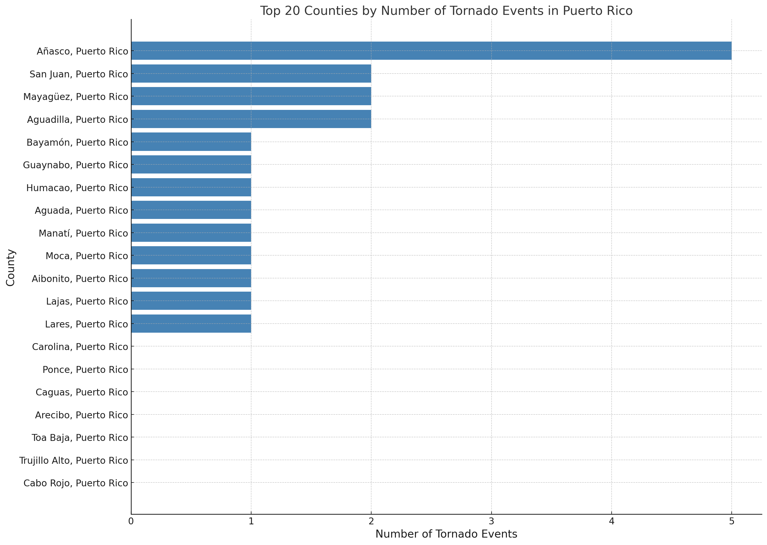

**Figure 6: Top 20 Counties in Puerto Rico by Frequency of Tornado Events**

The above chart displays the top 20 counties in Puerto Rico by tornado event frequency, with Anasco leading at 5 events, followed by San Juan with 4. Moderate activity is observed in counties like Mayagüez, Aguadilla, Bayamon, and Guaynabo, each reporting 2 events, while the rest, including Ponce, Caguas, and Arecibo, recorded 1 event. This distribution highlights significant tornado activity in specific regions, particularly Anasco and San Juan, which may warrant prioritized disaster preparedness and resource allocation.

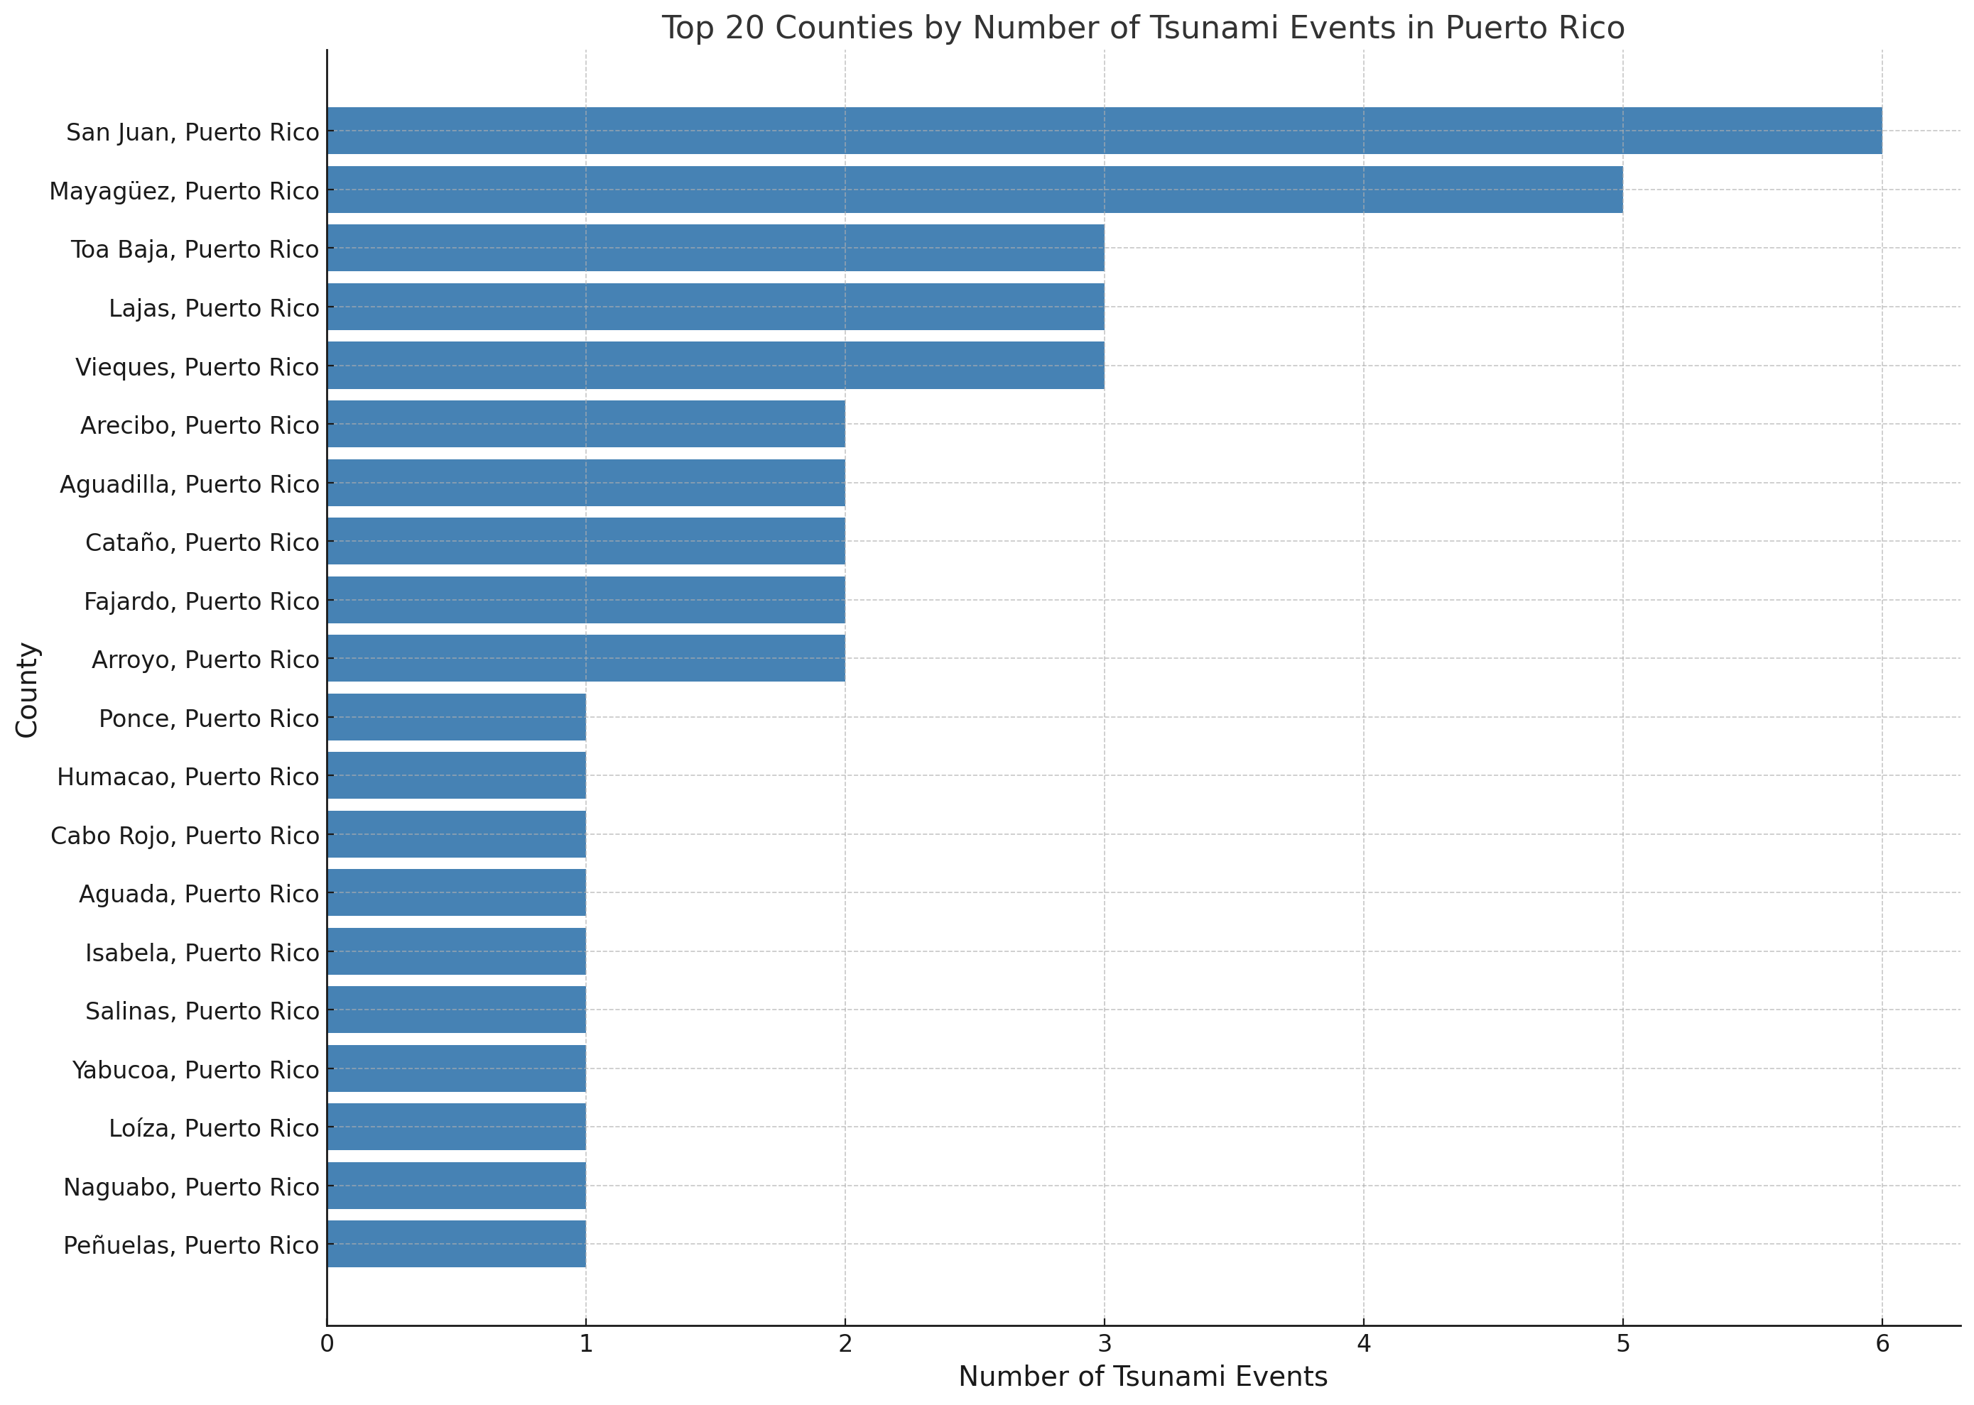

**Figure 7: Top 20 Counties in Puerto Rico by Frequency of Tsunami Events**

The above chart highlights the top 20 counties in Puerto Rico based on the number of recorded tsunami events. San Juan and Mayagüez lead with the highest frequency, recording 6 and 5 events, respectively. Moderate tsunami activity is observed in Toa Baja, Lajas, and Vieques, each with 3 events, while counties such as Arecibo, Aguadilla, and Cataño reported 2 events. The remaining counties, including Ponce, Cabo Rojo, and Yabucoa, recorded 1 event, indicating lower activity. This distribution underscores the variation in tsunami occurrence across Puerto Rico, with coastal areas such as San Juan and Mayagüez being the most affected, emphasizing the need for targeted tsunami preparedness and mitigation efforts in these regions.

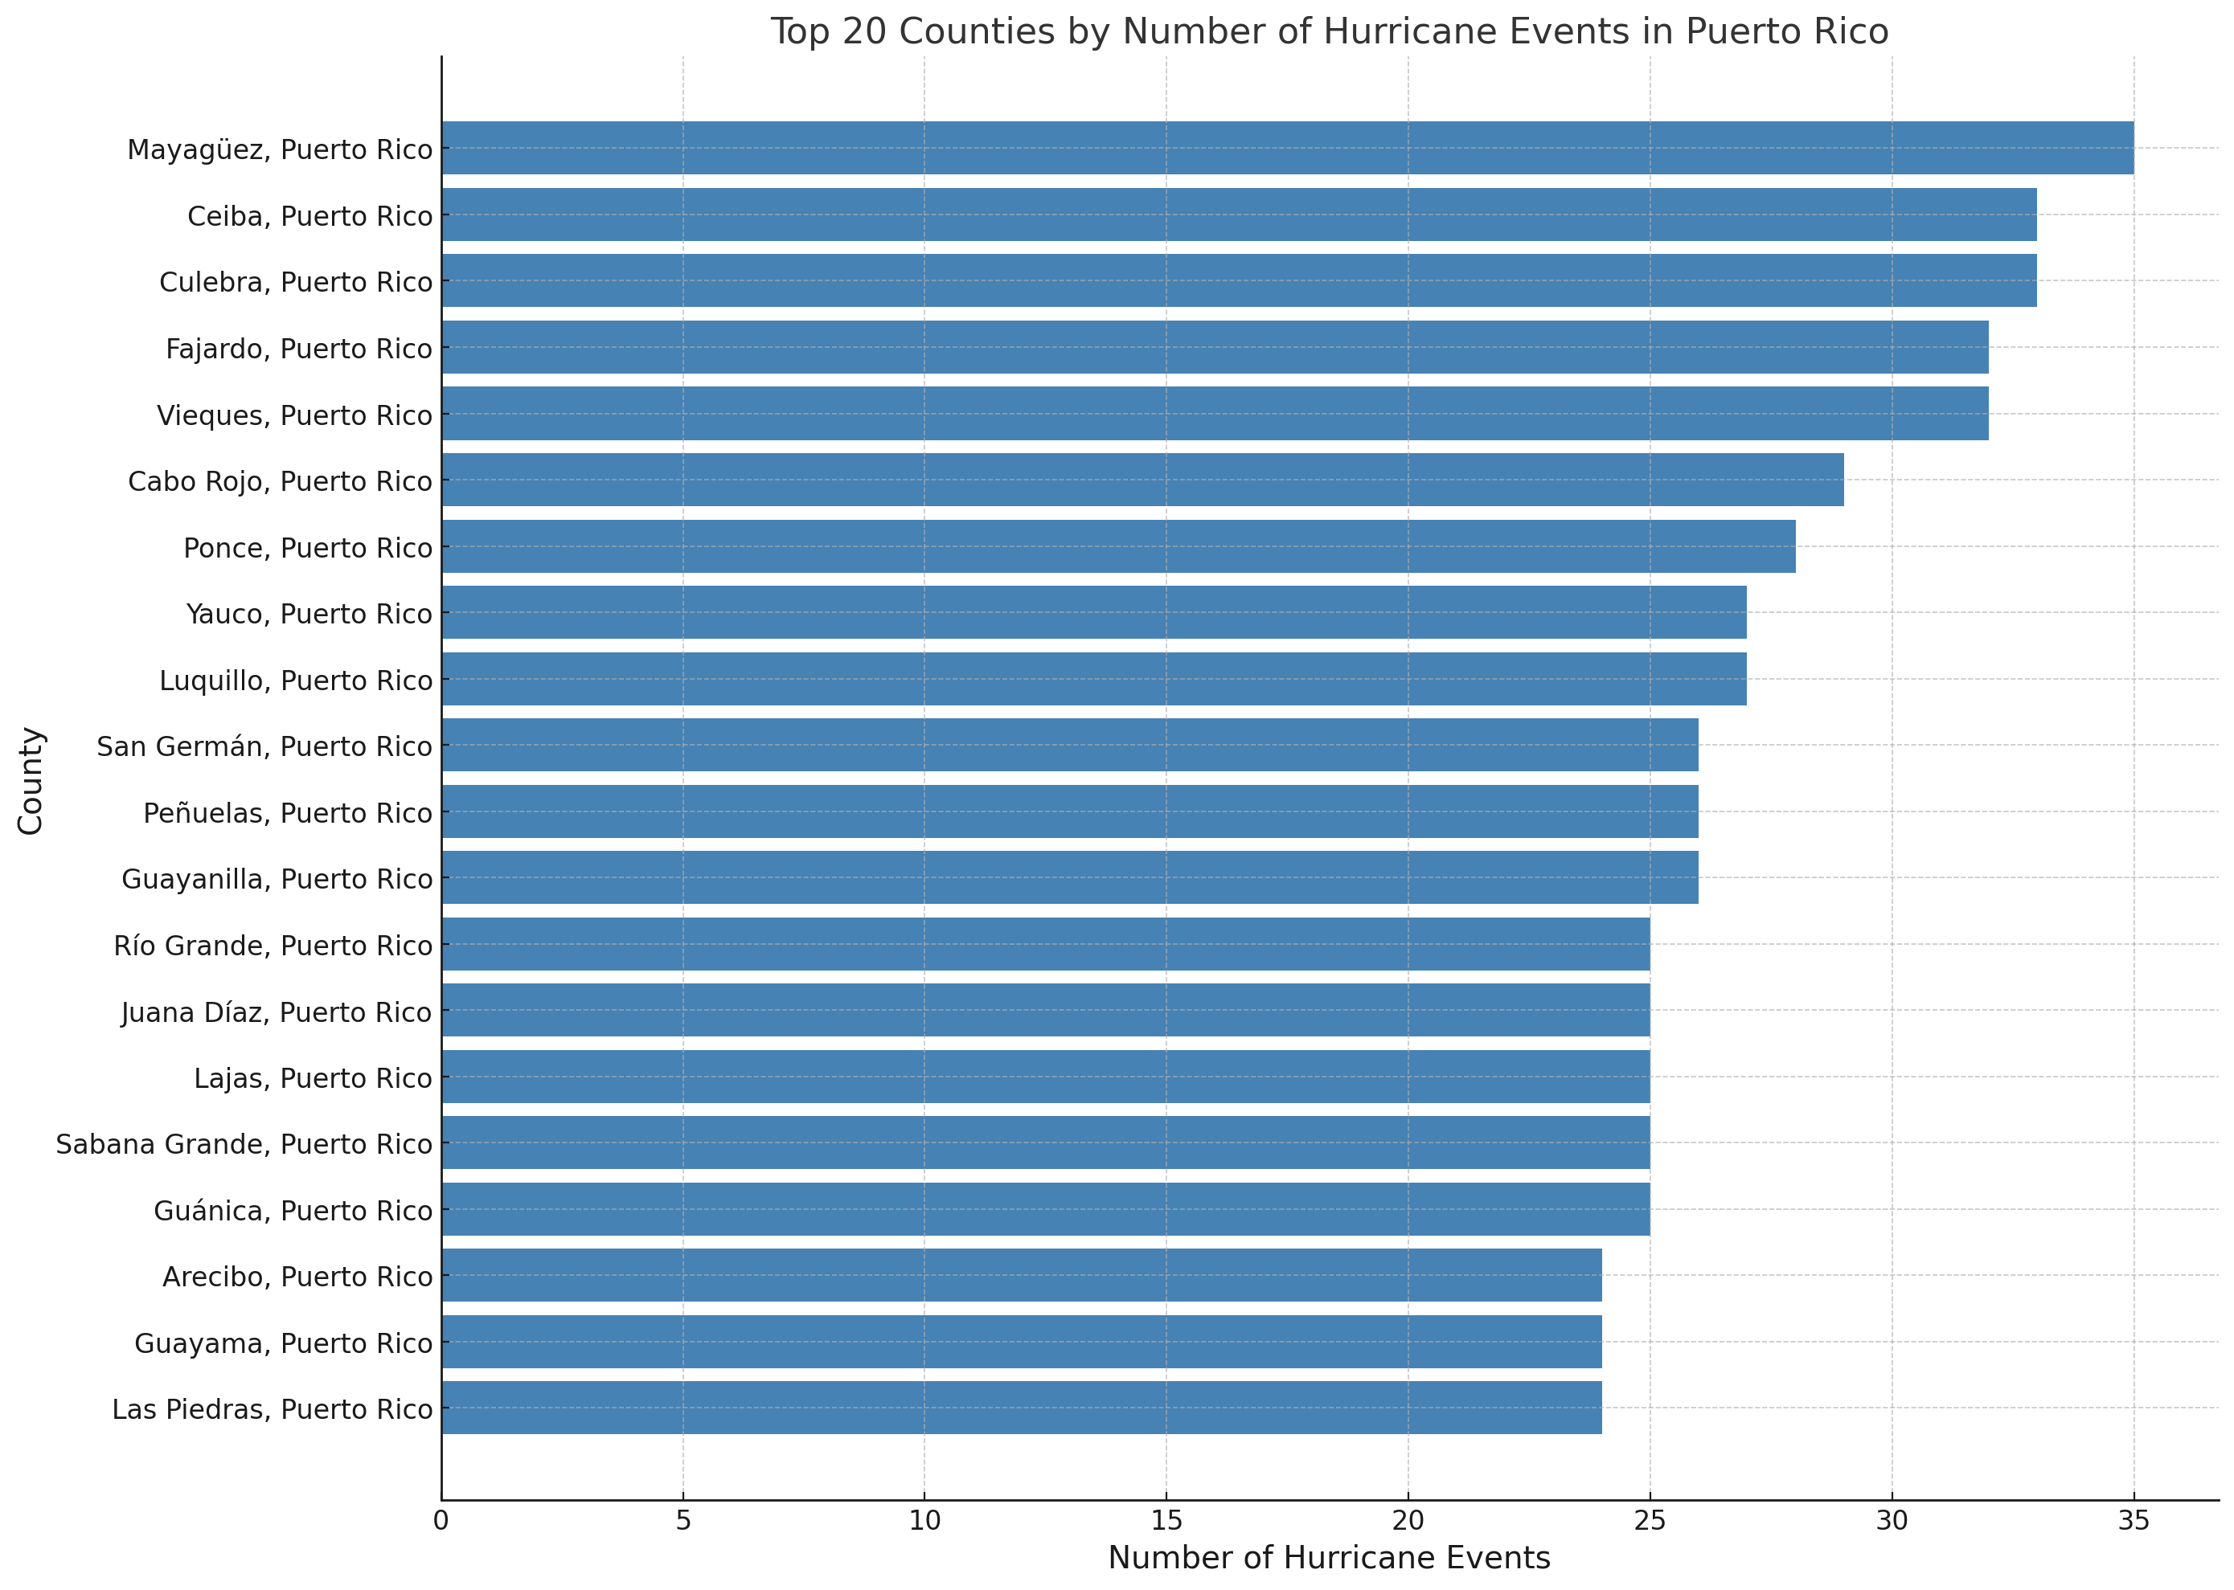

**Figure 8: Top 20 Counties in Puerto Rico by Frequency of Hurricane Events**

The above chart presents the top 20 counties in Puerto Rico with the highest number of recorded hurricane events. Mayagüez leads the list with the highest frequency, recording 34 events, followed by Ceiba and Culebra. Moderate activity is seen in counties like Fajardo, Vieques, Cabo Rojo, and Ponce, with counts ranging from 25 to 28 events. The remaining counties, such as Guanica, Arecibo, Guayama, and Las Piedras, show relatively lower hurricane activity with around 20 to 22 events. The data indicates that areas such as Mayaguez, Ceiba, and Culebra are highly prone to hurricanes, highlighting the need for enhanced disaster preparedness and mitigation measures in these regions.

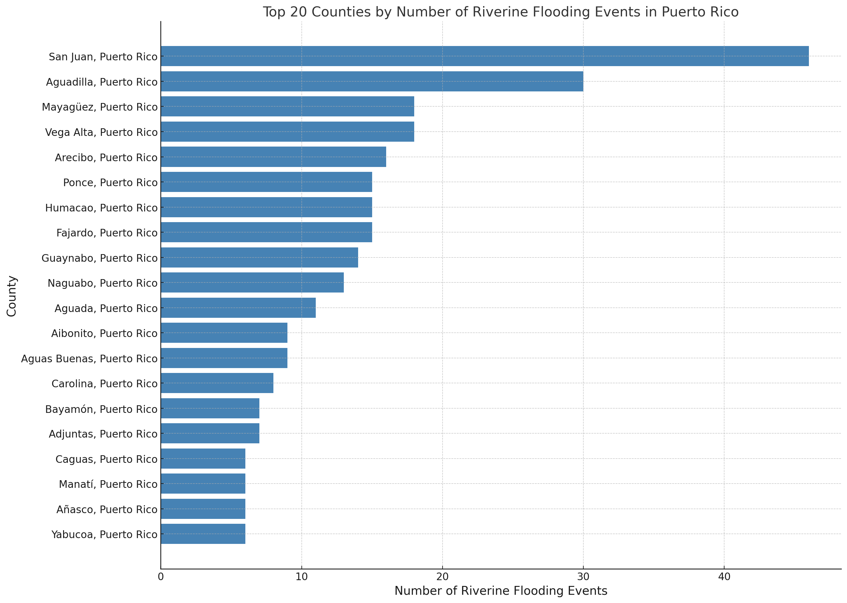

**Figure 9: Top 20 Counties in Puerto Rico by Frequency of Riverine Flooding Events**

The above chart illustrates the top 20 counties in Puerto Rico with the highest number of riverine flooding events. San Juan recorded the highest frequency, followed closely by Aguadilla. Moderate flooding activity is observed in Mayaguez, Vega Alta, and Arecibo. The remaining counties, including Carolina, Bayamon, and Adjuntas, report fewer events. This data underscores the vulnerability of regions like San Juan and Aguadilla to riverine flooding, emphasizing the importance of targeted flood management and mitigation efforts in these areas, particularly for urban and coastal regions prone to significant impacts.

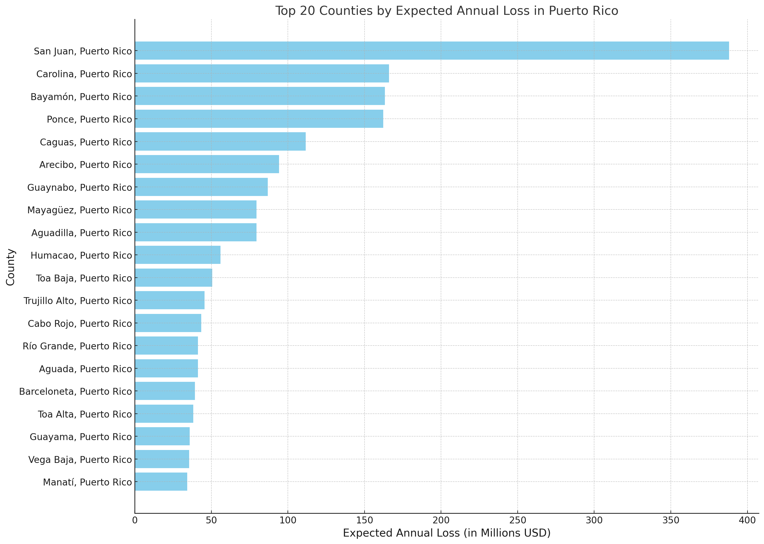

**Figure 10: Top 20 Counties in Puerto Rico by Expected Annual Loss (in Millions USD)**

The above chart highlights the top 20 counties in Puerto Rico ranked by their expected annual financial losses due to natural hazards or disasters. San Juan faces the highest potential annual loss, significantly surpassing other counties, followed by Carolina and Bayamon, which also exhibit substantial risk exposure. Counties such as Ponce, Caguas, and Arecibo demonstrate moderate levels of financial vulnerability, while areas like Guaynabo, Mayaguez, and Aguadilla show relatively lower but still significant expected losses. These insights emphasize the need for focused disaster mitigation strategies and resource allocation, particularly in high-risk areas like San Juan, to minimize economic impacts and safeguard infrastructure.

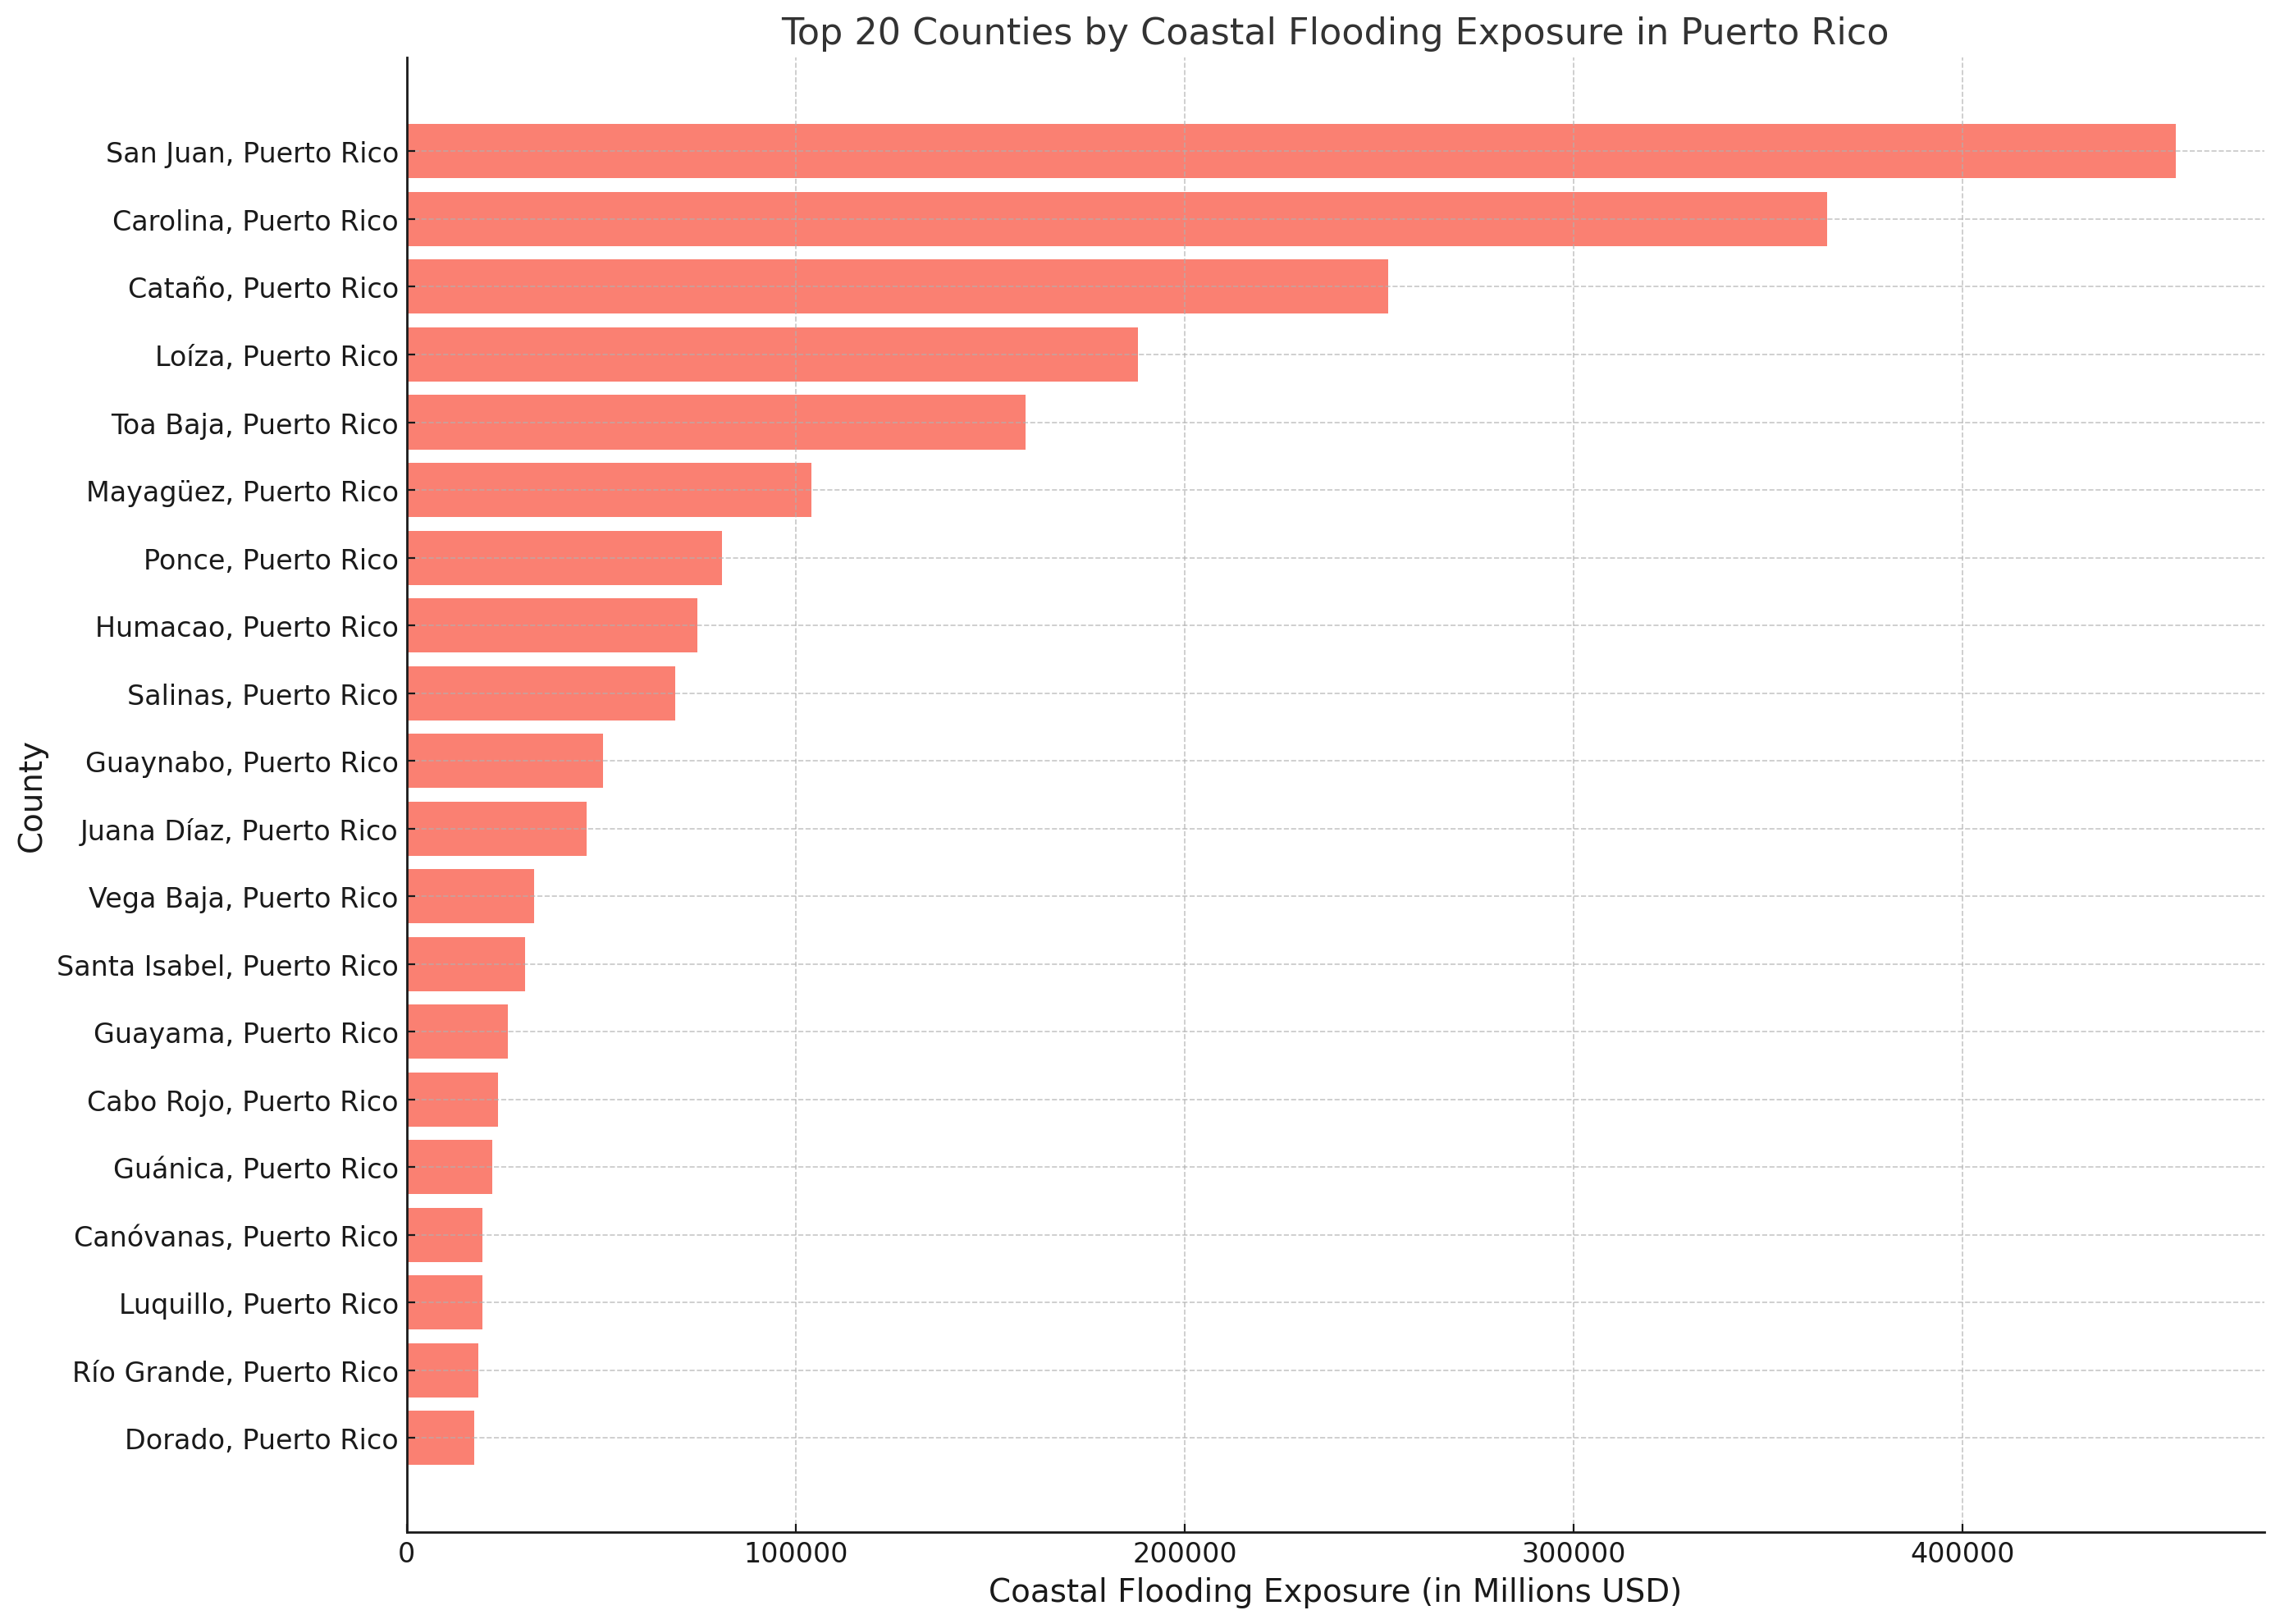

**Figure 11: Top 20 Counties in Puerto Rico by Coastal Flooding Exposure (in Millions USD)**

The above chart showcases the top 20 counties in Puerto Rico with the highest financial exposure to coastal flooding. San Juan experiences the greatest risk, followed closely by Carolina and Cataño, which also face substantial economic vulnerabilities. Other counties such as Loiza, Toa Baja, and Mayagüez demonstrate moderate levels of exposure, while regions like Ponce, Humacao, and Salinas show relatively lower, yet significant, potential impacts. The distribution highlights the disproportionate exposure of coastal areas, underscoring the need for targeted flood mitigation strategies and infrastructure reinforcement in the most at-risk regions, particularly San Juan and neighboring counties.

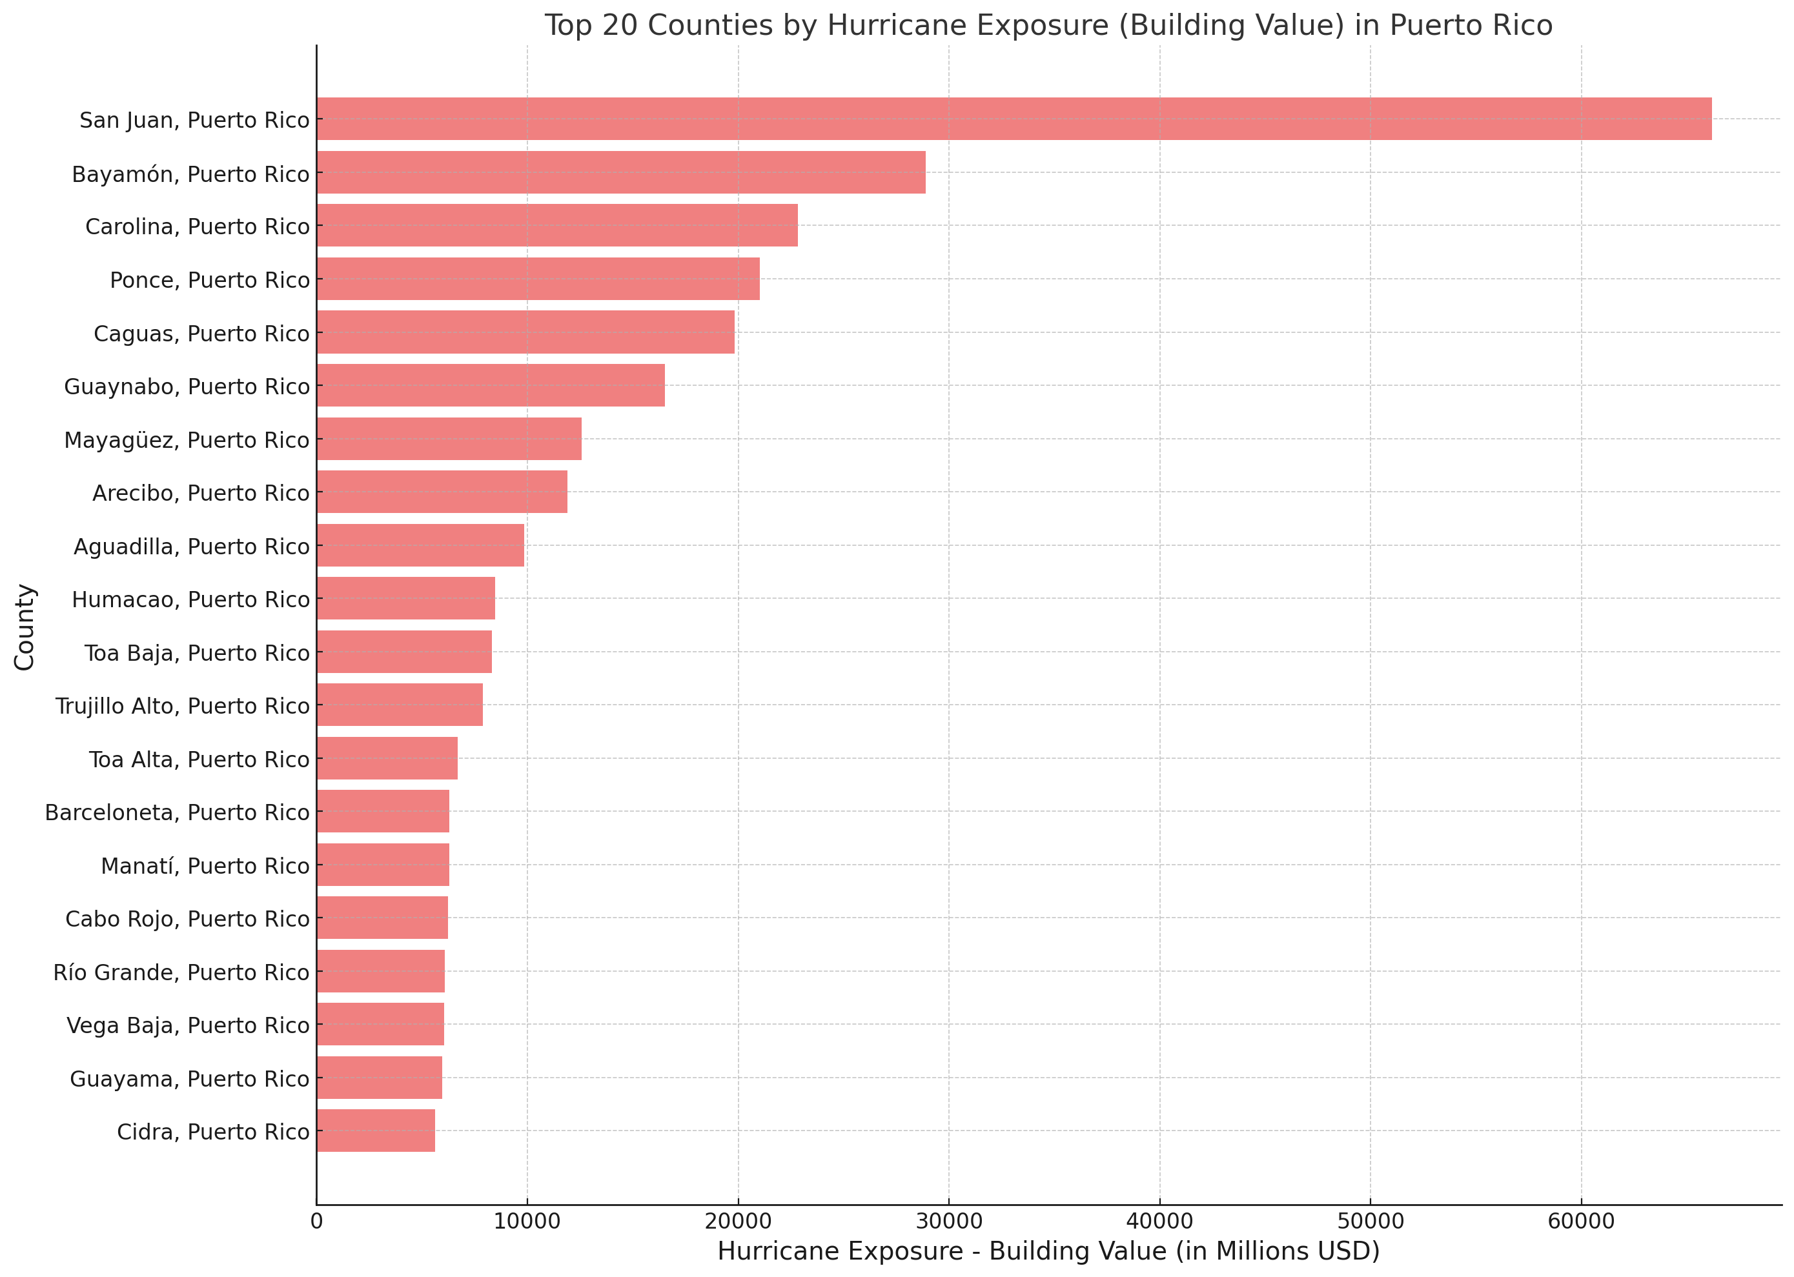

**Figure 12: Top 20 Counties by Hurricane Exposure (Building Value) in Puerto Rico**

The above chart highlights the top 20 counties in Puerto Rico with the highest building value exposure to hurricanes. San Juan exhibits the greatest vulnerability, with significantly higher exposure compared to other counties, followed by Bayamon and Carolina, which also face substantial risks. Counties such as Ponce, Caguas, and Guaynabo show moderate exposure, while regions like Mayagüez, Arecibo, and Aguadilla have relatively lower but still significant building value at risk. The data underscores the critical need for targeted hurricane resilience strategies and infrastructure protection measures in highly exposed areas like San Juan, as well as other urban and coastal regions.

## Visualizations – Internal Dataset(PRSTRT)

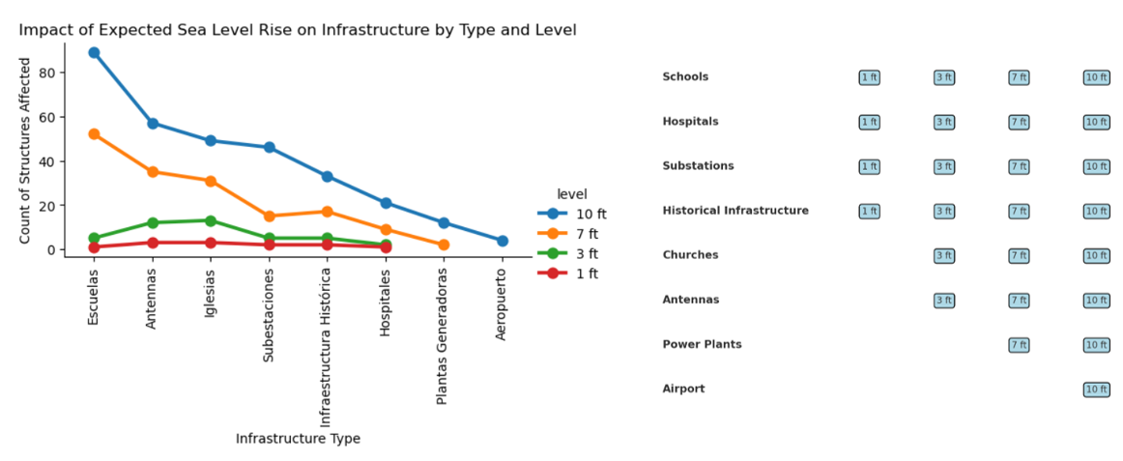

**Figure 13: Impact of Expected Sea Level Rise on Infrastructure by Type and Elevation Levels in Puerto Rico**

The above chart illustrates the impact of expected sea level rise (ranging from 1 ft to 10 ft) on various infrastructure types in Puerto Rico, highlighting the count of structures affected. Schools are the most impacted infrastructure type, with significant vulnerability across all elevation levels, particularly at higher levels of sea rise (7 ft and 10 ft). Antennas, churches, and substations also show noticeable exposure, with a gradual increase in affected counts as the sea level rise progresses. Critical infrastructures like hospitals, power plants, and the airport demonstrate relatively lower vulnerability compared to schools, but their impact becomes evident at higher sea level rises. The findings emphasize the pressing need to prioritize adaptation measures for highly vulnerable infrastructure, such as schools and substations, while also preparing critical facilities like hospitals and power plants for higher sea level rise scenarios.

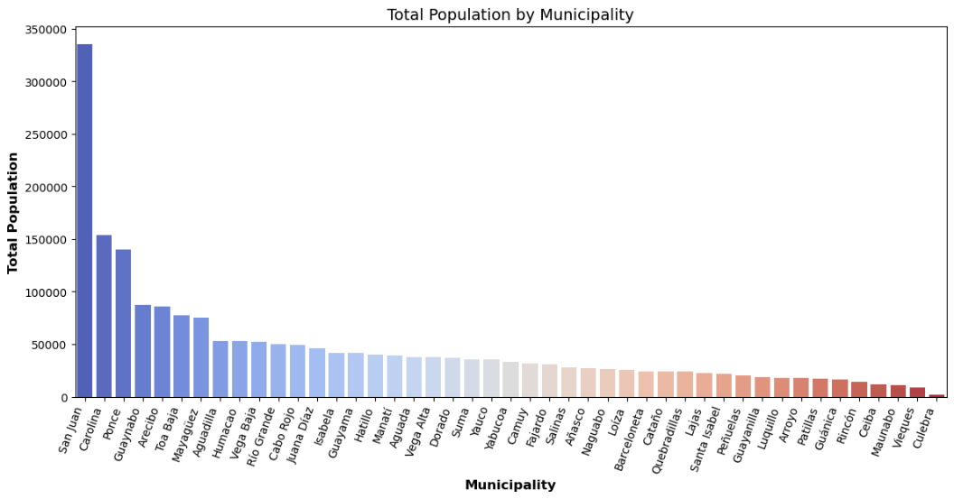

**Figure 14: Total Population Distribution by Municipality in Puerto Rico**

The above chart displays the total population distribution across municipalities in Puerto Rico. San Juan leads with the highest population, significantly surpassing other municipalities, followed by Carolina and Ponce, which also have substantial populations. Municipalities such as Guaynabo, Arecibo, and Toa Baja represent moderate population centers, while regions like Maunabo, Vieques and Culebra have notably smaller populations.

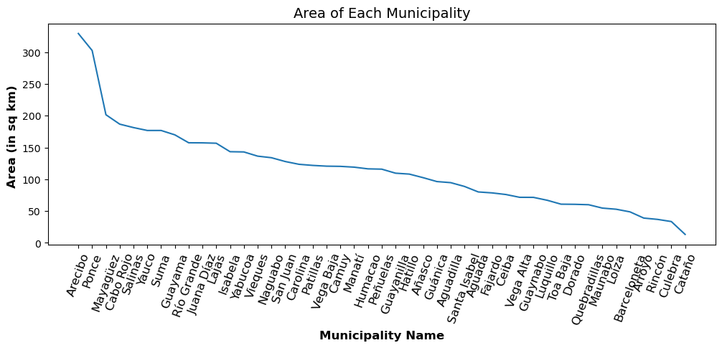

**Figure 15: Area of Each Municipality in Puerto Rico (in Square Kilometers)**

The above chart presents the land area of municipalities in Puerto Rico, highlighting significant variations. Arecibo has the largest area covering 329.5 square kilometers, followed by Ponce and Mayagüez, indicating these municipalities cover substantial geographic regions. Municipalities such as Cabo Rojo, Salinas, and Yauco also possess moderately large areas. Smaller municipalities like Cataño, Loiza, and Rincón have significantly reduced land areas, indicating a compact geographic footprint.

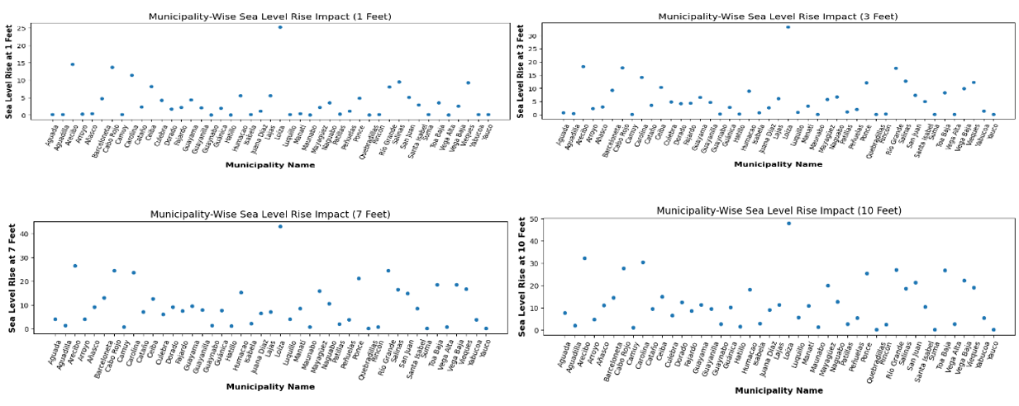

**Figure 16: Municipality-Wise Impact of Sea Level Rise at Various Elevation Levels in Puerto Rico**

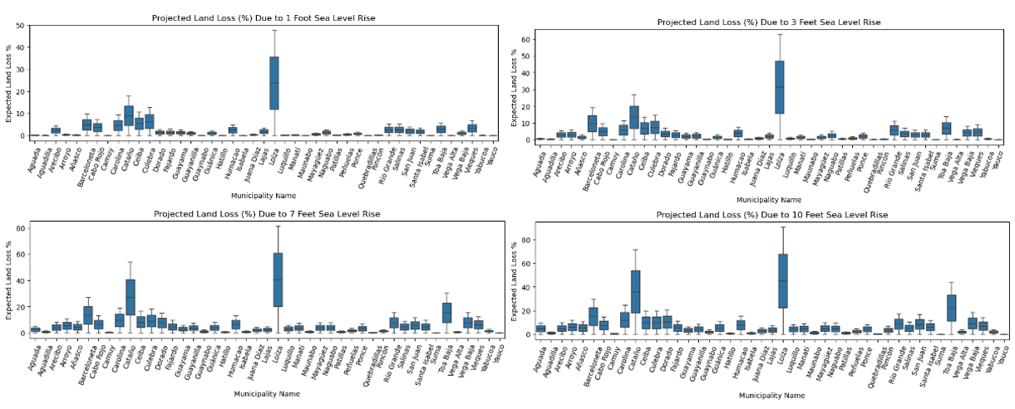The above visualization highlights the municipality-wise impact of sea level rise at four elevation levels: 1 ft, 3 ft, 7 ft, and 10 ft. Loiza, Arecibo, and Cabo Rojo consistently emerge as the most affected municipalities across all levels, while municipalities such as Quebradillas, Vega Alta, and Maunabo show minimal impact at lower levels (1 ft and 3 ft). At 7 ft, Río Grande becomes notably affected, whereas Yauco and Suma remain among the least impacted. The findings emphasize the increased vulnerability of certain municipalities, particularly Loiza and Arecibo, as sea levels rise, underscoring the need for targeted resilience strategies in highly affected regions to mitigate the impacts of future sea level rise.

**Figure 17: Projected Percentage of Land Loss For Various Municipalities In Puerto Rico At Different Sea Level Rise Levels**

The above visualization presents the projected percentage of land loss across municipalities in Puerto Rico under different sea level rise scenarios (1 ft, 3 ft, 7 ft, and 10 ft). Loiza consistently experiences the highest expected land loss, with percentages increasing from 47.76% at 1 ft to 90.66% at 10 ft, indicating extreme vulnerability. In contrast, municipalities such as Vega Alta, Quebradillas, and Hatillo report minimal land loss, with percentages ranging from 0.07% to 0.38% for lower sea levels and remaining under 5% even at 10 ft. These findings highlight significant disparities in vulnerability, with Loiza requiring urgent mitigation measures, while municipalities like Vega Alta and Hatillo face comparatively lower risks from sea level rise.

## Visualization – School Shelters Data

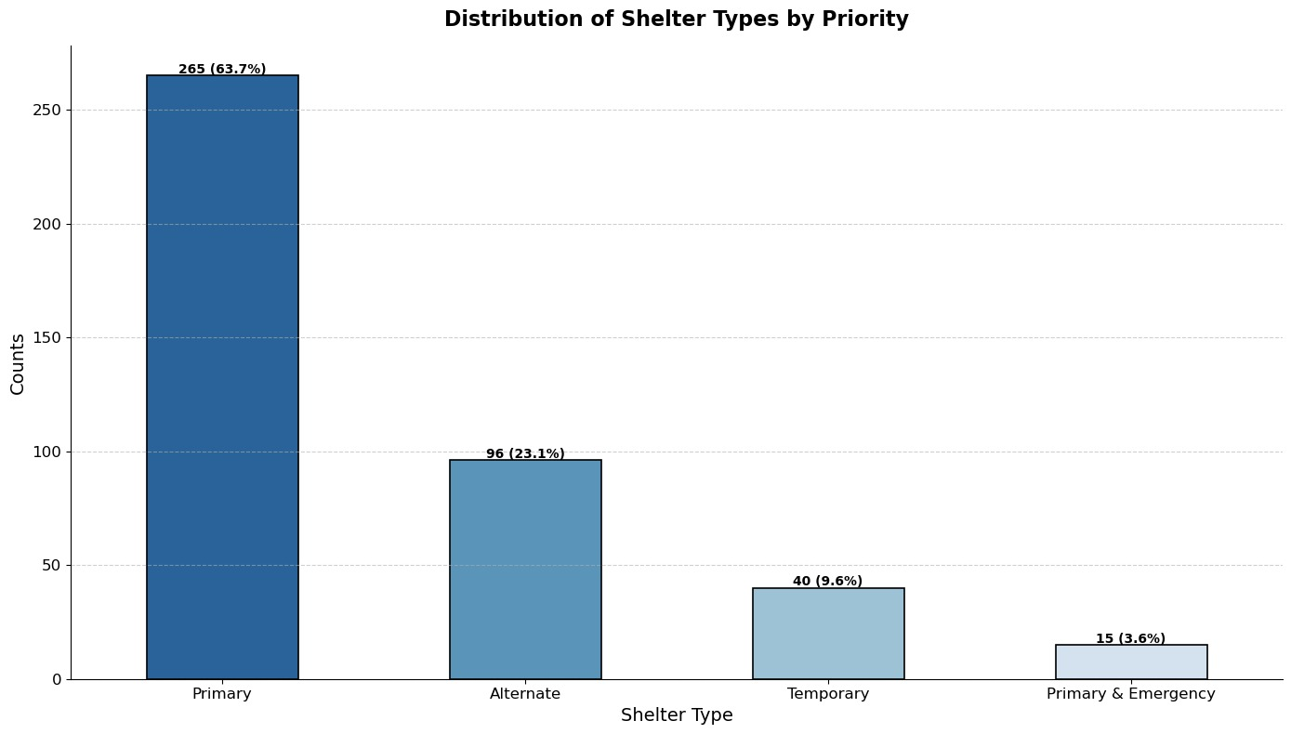

**Figure 18: Distribution of Shelter Types by Priority in Puerto Rico**

The chart depicts the distribution of shelter types by priority in Puerto Rico, showing that Primary shelters account for the largest proportion, with 265 shelters (63.7%), emphasizing their importance in emergency response planning. Alternate shelters represent the second largest category, with 96 shelters (23.1%), followed by Temporary shelters at 40 shelters (9.6%). The smallest category is Primary & Emergency shelters, with 15 shelters (3.6%), highlighting their limited availability. The data underscores the reliance on primary shelters for disaster preparedness while showcasing the need for maintaining and possibly increasing alternate and emergency shelter capacities to enhance resilience.

# Findings

The analysis conducted for this project has yielded critical insights into population distribution, infrastructure vulnerability, social vulnerability, and natural hazard exposure across Puerto Rico. These findings provide a comprehensive overview of the challenges facing the region, highlighting areas of concern and informing targeted strategies for resilience and adaptation investments.

**Population Distribution and Demographics**

The analysis reveals that Puerto Rico's population is heavily concentrated in the San Juan metropolitan area, underscoring the importance of focusing resilience investments in this densely populated region. This demographic concentration amplifies the potential impact of natural hazards, as densely populated areas are more vulnerable to large-scale disruptions in infrastructure and services. Understanding this population distribution helps prioritize resource allocation and disaster response strategies in regions where the need is greatest.

**Infrastructure Vulnerability and Tier Ratings**

The vulnerability analysis of infrastructure assets, categorized into tiers based on their exposure and criticality, provides actionable insights for prioritizing interventions:

* **Airports:** Airports in Puerto Rico are generally located at higher altitudes, making them less susceptible to flooding from 1-ft and 3-ft sea level rise scenarios. This relative safety ensures continued connectivity and emergency response capabilities during moderate flooding events.
* **Tier 1 Infrastructure:** Among Tier 1 assets, hospitals are the most affected by 1-ft and 3-ft sea level rise. This vulnerability is significant, as hospitals are critical for disaster response and public health. In contrast, power plants are only impacted in more extreme scenarios, such as 7-ft and 10-ft sea level rise. This variation in vulnerability underscores the need for tailored mitigation strategies for different infrastructure types.
* **Schools:** Schools are the most prevalent type of infrastructure across Puerto Rico, forming a critical component of the social fabric and serving as community centers during disasters. Their widespread presence and potential vulnerability highlight the importance of ensuring their resilience to natural hazards.

**Social Vulnerability**

Social vulnerability scores across Puerto Rico are generally high, indicating widespread challenges in coping with natural hazards. These scores reflect socio-economic factors such as income levels, access to resources, and community resilience. Regions with high social vulnerability may struggle to recover from disasters, further emphasizing the need for targeted investments in these communities to enhance resilience and adaptive capacity. This finding is critical for equitable disaster planning and ensuring that resources are directed toward the most vulnerable populations.

**Natural Hazards Exposure**

The exposure analysis identifies key regions and types of hazards that pose significant risks to Puerto Rico:

* **Population Exposure:** San Juan, Bayamón, and Carolina have the highest population exposure to natural hazards, including hurricanes, flooding, and coastal storm surges. These areas require prioritized investments in resilient infrastructure and emergency planning to safeguard their large populations.
* **Regional Hazards:** Mayagüez emerges as the region experiencing the highest number of natural hazard events. This frequency of hazards makes it a critical area for targeted risk mitigation efforts and infrastructure reinforcement.
* **Coastal Flooding:** Coastal flooding is identified as the most frequent natural hazard affecting Puerto Rico. This recurring issue underscores the need for robust flood mitigation measures, particularly in low-lying coastal areas where populations and infrastructure are at the greatest risk.

**Implications for Resilience and Adaptation**

These findings collectively highlight key areas of concern for prioritizing resilience and adaptation investments:

* San Juan and other densely populated regions must receive targeted resources to address their high population exposure and vulnerability.
* Hospitals and other critical Tier 1 infrastructure require immediate attention to mitigate the risks posed by moderate sea level rise scenarios.
* Investments in flood prevention and infrastructure reinforcement in Mayagüez and other regions with high natural hazard frequency are essential.
* Addressing the high social vulnerability across Puerto Rico will ensure that the most affected communities are better equipped to recover from disasters.

By identifying these critical vulnerabilities and areas of concern, this analysis provides a roadmap for informed decision-making and strategic resource allocation to enhance Puerto Rico’s infrastructure safety and resilience.

# Summary

The **Puerto Rico Sea Level Rise Center - Data Portal Dashboard** project aimed to tackle critical challenges associated with natural hazard resilience and infrastructure prioritization in Puerto Rico. Leveraging diverse datasets, including FEMA hazard data, social vulnerability indices, and infrastructure records, the project successfully developed an interactive Power BI dashboard to assist policymakers, urban planners, and emergency managers in making informed, data-driven decisions.

The primary objective of the project was to assess the vulnerability of public infrastructure and communities to natural hazards such as sea level rise, coastal flooding, and hurricanes. By ranking critical public assets—including hospitals, schools, and power plants—based on their risk exposure and importance, the dashboard provides a practical tool for prioritizing resilience investments. To achieve this, extensive datasets were collected and preprocessed, encompassing infrastructure locations, demographic details, and hazard exposure levels. These datasets were meticulously cleaned, normalized, and transformed into standardized formats to ensure consistency and compatibility across all data sources, resulting in reliable data integration for visualization and analysis.

The interactive dashboard was designed with three core pages to deliver actionable insights.

* **Page 1 (Tier Ratings and Infrastructure Map)** visualized infrastructure assets, categorizing them into tiers based on importance and vulnerability. ArcGIS maps enabled spatial exploration, helping prioritize high-risk assets such as hospitals and schools.
* **Page 2 (County-Level Insights)** provided demographic and vulnerability data for each county, highlighting regions most exposed to natural hazards and high social vulnerability. This page allowed stakeholders to compare regions and allocate resources equitably.
* **Page 3 (Shelters in Puerto Rico)** displayed shelter locations, capacities, and categories, identifying gaps in emergency housing infrastructure and highlighting regions needing additional preparedness resources.

Key findings from the analysis included significant insights into infrastructure vulnerability, social vulnerability, and hazard exposure. Airports were determined to be largely unaffected by 1-ft and 3-ft sea level rise due to their higher altitudes, while hospitals and power plants were found to face varying levels of risk, particularly in scenarios involving 7-ft and 10-ft sea level rise. High social vulnerability scores in regions like San Juan, Bayamón, and Carolina revealed challenges for communities in coping with natural hazards, emphasizing the importance of targeted resilience planning. Coastal flooding emerged as the most frequent hazard, particularly in low-lying areas, posing persistent risks to both infrastructure and communities.

This project demonstrated the feasibility of integrating diverse datasets into a cohesive, interactive platform for analysis and visualization. The tier-based ratings proved to be effective in prioritizing infrastructure investments based on risk and importance, while the integration of demographic and shelter data highlighted critical areas requiring intervention. By equipping stakeholders with actionable insights, the dashboard serves as a comprehensive and user-friendly tool to reduce risks, improve resilience, and support data-driven decision-making for protecting Puerto Rico’s infrastructure and communities.

# Future Work

The Puerto Rico Sea Level Rise Center - Data Portal Dashboard has successfully addressed critical challenges in infrastructure prioritization and natural hazard resilience. However, further enhancements and expansions are necessary to ensure continued relevance, scalability, and impact. The following areas for future work are proposed:

**Integration of Real-Time Data**

* Incorporating real-time data streams, such as live weather updates, tide gauges, and disaster alerts, would enhance the dashboard's utility. This real-time integration can allow stakeholders to monitor hazards dynamically and adapt their decisions in response to evolving conditions.

**Inclusion of Additional Hazards and Scenarios**

* While the current dashboard focuses on sea level rise, coastal flooding, and hurricanes, future iterations should include other natural hazards, such as earthquakes, landslides, and tsunamis. Expanding the scope to cover these hazards will provide a more comprehensive risk assessment for Puerto Rico.

**Cost-Benefit Analysis for Investment Decisions**

* Adding a cost-benefit analysis feature can help stakeholders weigh the financial implications of infrastructure upgrades versus the expected benefits in terms of risk reduction and resilience. This addition would assist in making more economically sound decisions.

**Enhanced Socio-Economic Metrics**

* Future work could incorporate more detailed socio-economic data, such as income distribution, housing types, and access to healthcare, to refine social vulnerability assessments. This expansion will ensure that resource allocation is even more equitable and targeted.

**Community Engagement and Feedback Mechanism**

* Incorporating a user feedback loop will enable policymakers and community members to suggest improvements, validate findings, and align the dashboard’s outputs with on-the-ground realities. This engagement ensures that the tool remains relevant and impactful.

**Machine Learning Integration for Predictive Insights**

* While the current model is rule-based, integrating machine learning algorithms could allow for predictive modeling of infrastructure risks under various climate scenarios. This capability would enable more proactive planning for long-term climate resilience.

Expanding Geographic Scope

* The framework can be expanded to other Caribbean islands or regions with similar vulnerabilities. This scalability would allow broader applicability of the tool and facilitate regional collaboration in disaster resilience planning.

**Mobile Platform Development**

* Developing a mobile-friendly version of the dashboard would improve accessibility for field teams, emergency responders, and remote stakeholders. This enhancement would ensure that the dashboard is usable in diverse settings, including during disaster response operations.

**Automated Reporting Features**

* Adding the ability to generate customized, automated reports directly from the dashboard will save time for users and enhance the efficiency of decision-making processes. These reports could summarize risk analyses, tier rankings, and resource allocation plans for policymakers.

**Partnerships and Data Sharing**

* Building partnerships with local government agencies, NGOs, and international organizations can facilitate access to additional datasets and resources. This collaboration would further enhance the accuracy and relevance of the dashboard.

By implementing these enhancements, the dashboard can evolve into a more robust, adaptive, and user-centric tool, empowering stakeholders to make data-informed decisions to mitigate risks and enhance resilience across Puerto Rico and beyond.

**This page intentionally left blank**

Appendix

Appendix A: Domain Background

**A.1 Introduction to Sea Level Rise and Coastal Flooding**

Sea level rise and coastal flooding are two interconnected phenomena exacerbated by climate change, posing severe threats to coastal regions worldwide. Puerto Rico, a U.S. territory in the Caribbean with over 480 kilometers of coastline, is particularly vulnerable to coastal flooding, hurricanes, and rising sea levels due to its geographical location in the Caribbean. Rising sea levels result from the thermal expansion of ocean waters and the melting of glaciers and polar ice caps. As ocean levels rise, coastal communities face increased risks of flooding, erosion, and saltwater intrusion, affecting infrastructure, agriculture, and public

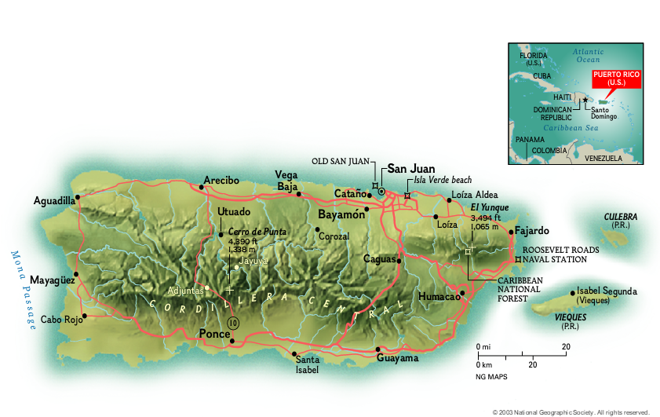

Figure 19: Puerto Rico's geographical location and topography

In Puerto Rico, the impact of sea level rise is compounded by extreme weather events like hurricanes and tropical storms, which lead to storm surges and intensified flooding. Climate-related disasters, such as Hurricanes Irma and Maria in 2017, caused widespread damage across the island, severely affecting the economy, infrastructure, and livelihoods. These events demonstrated the island's vulnerability to both short-term weather phenomena and long-term sea-level rise.

This appendix provides a comprehensive overview of the factors contributing to sea level rise and coastal flooding in Puerto Rico, including climate change, coral reef degradation, and socio-economic implications. This background will help readers unfamiliar with the domain understand the risks and challenges Puerto Rico faces and the significance of the project.

**A.2 Climate Change and Sea Level Rise**

**A.2.1 Mechanisms of Sea Level Rise**

Climate change is the primary driver of global sea level rise. There are two main processes responsible for rising sea levels:

Thermal Expansion: As global temperatures rise, ocean water expands, contributing to higher sea levels. This process accounts for about half of the observed global sea level rise.

Melting of Land-Based Ice: The melting of glaciers and ice sheets in regions like Greenland and Antarctica adds freshwater to the oceans, further raising sea levels.

According to the National Oceanic and Atmospheric Administration (NOAA), global sea levels have risen approximately 8-9 inches (21-24 cm) since 1880. This trend is expected to accelerate, with projections indicating that sea levels could rise by an additional 1-8 feet by the end of the century, depending on future greenhouse gas emissions and the rate of ice sheet melt.

**A.2.2 Impact of Sea Level Rise on Puerto Rico**

For Puerto Rico, sea level rise presents a critical risk due to the island's extensive coastal development and high population density in coastal areas. The combination of rising sea levels, coastal erosion, and the increasing frequency of extreme weather events intensifies the risk of flooding and property damage. Puerto Rico's tourism industry, which relies heavily on its coastal assets, is also at risk.

In addition to the direct impacts on infrastructure and livelihoods, rising sea levels contribute to saltwater intrusion into freshwater aquifers, threatening water supply and agriculture. This has significant implications for food security and public health, particularly in rural and low-lying communities.

**A.3 Coastal Flooding and Extreme Weather Events**

**A.3.1 Coastal Flooding**

Coastal flooding occurs when sea levels rise temporarily during storms or high tides, inundating low-lying areas. This type of flooding can result from storm surges, high waves, or long-term sea level rise. In Puerto Rico, coastal flooding is a recurring problem due to the island's exposure to hurricanes and tropical storms. The severity of these events is increasing, driven by climate change.

**A.3.2 Hurricanes and Storm Surges**

Hurricanes, which are intense tropical storms, are one of the primary causes of coastal flooding in Puerto Rico. Storm surges generated by hurricanes push seawater onto land, leading to widespread flooding. The destructive power of hurricanes is not only in their wind speeds but also in the volume of water they move, both from the ocean and heavy rainfall.

Hurricane Maria in 2017 is a notable example of the devastation that hurricanes can cause in Puerto Rico. The Category 4 storm made landfall near Yabucoa, bringing torrential rains and storm surges that led to extreme coastal flooding and inland flash flooding. The hurricane caused over $90 billion in damages, with the island still recovering years later.

**A.4 Coral Reef Degradation**

**A.4.1 Importance of Coral Reefs in Coastal Protection**

Coral reefs play a critical role in coastal protection by acting as natural barriers that reduce wave energy. Healthy coral reefs can dissipate up to 97% of wave energy, helping to prevent coastal erosion and flooding. This protective function is particularly important for Puerto Rico, where extensive coral reefs provide a buffer against hurricanes and storm surges.

**A.4.2 Impact of Coral Reef Degradation**

Unfortunately, Puerto Rico’s coral reefs have suffered significant degradation due to hurricanes, climate change, and human activities. The 2017 hurricanes, particularly Maria, caused widespread damage to coral reefs, further exposing coastal areas to the effects of waves and storm surges. Coral bleaching, a phenomenon caused by rising ocean temperatures, also contributes to reef degradation, weakening the resilience of coastal ecosystems.

The degradation of coral reefs has serious implications for flood risks in Puerto Rico. Without these natural barriers, coastal areas are more vulnerable to wave action, leading to increased flooding and erosion. Restoring and protecting coral reefs is therefore a key component of climate adaptation strategies for Puerto Rico.

**A.5 Socio-Economic Impacts of Climate Change in Puerto Rico**

The socio-economic impacts of climate change in Puerto Rico are profound, affecting every sector of society. Key areas of concern include:

**A.5.1 Infrastructure Damage and Economic Losses**

Rising sea levels, hurricanes, and flooding pose significant risks to critical infrastructure such as roads, bridges, hospitals, and schools. According to a report by the Union of Concerned Scientists, over 325 critical infrastructure assets in Puerto Rico are at risk of damage or disruption by 2045 due to rising sea levels. The economic cost of rebuilding and repairing infrastructure after extreme weather events is enormous, with damages from Hurricane Maria alone exceeding $90 billion.

These economic losses are compounded by disruptions to businesses and tourism, which play a significant role in Puerto Rico's economy. The displacement of communities and loss of livelihoods further exacerbate the socio-economic impacts of climate change.

**A.5.2 Public Health Risks**

The health of Puerto Rico's population is also at risk due to climate change. Rising temperatures increase the likelihood of heat-related illnesses, particularly among vulnerable populations such as the elderly and those with pre-existing health conditions. Flooding can lead to the contamination of freshwater supplies, resulting in waterborne diseases. The stress of frequent natural disasters also contributes to mental health issues in affected communities.

**A.6 Environmental Injustice and Vulnerable Communities**

Climate change disproportionately affects vulnerable communities in Puerto Rico, particularly low-income populations and marginalized groups. These communities often live-in areas with poor infrastructure, making them more susceptible to the impacts of flooding and extreme weather events. Limited access to resources and information further hinders their ability to prepare for and recover from climate-related disasters.

Environmental justice is a critical consideration in climate resilience planning. Ensuring that all communities, especially the most vulnerable, are included in decision-making processes is essential for developing equitable solutions to the challenges posed by climate change.

**A.7 Conclusion**

Puerto Rico faces a complex set of challenges related to climate change, including rising sea levels, coastal flooding, and coral reef degradation. The socio-economic and environmental impacts of these challenges are significant, affecting the island’s infrastructure, economy, and public health. Addressing these issues requires a comprehensive, data-driven approach that incorporates real-time monitoring, predictive modeling, and stakeholder collaboration.

Understanding the domain background is crucial for developing effective strategies to mitigate the risks associated with sea level rise and coastal flooding in Puerto Rico. This appendix has provided an overview of the key factors contributing to these challenges, setting the stage for the detailed analysis and solutions presented in the report.

Appendix B: Glossary

|  |  |
| --- | --- |
| Term | Definition |
| Sea Level Rise (SLR) | The increase in the average height of the ocean over time, primarily caused by the thermal expansion of seawater and the melting of glaciers and ice sheets. It is a significant consequence of climate change, leading to coastal flooding, erosion, and the displacement of communities. |
| Thermal Expansion | The process by which water expands as it warms. As the Earth's temperature increases due to climate change, the volume of ocean water increases, contributing to sea level rise. |
| Glacial Melting | The melting of large ice formations (glaciers) on land, particularly in Greenland and Antarctica, that adds freshwater to the oceans, further contributing to sea level rise. |
| Coastal Flooding | A type of flooding that occurs when seawater temporarily inundates low-lying coastal areas, often caused by storm surges, high tides, or sea level rise. |
| Storm Surge | An abnormal rise in sea level during a storm, typically caused by strong winds pushing water onshore. |
| Coral Reefs | Marine ecosystems composed of colonies of tiny animals called coral polyps. They provide critical protection against coastal erosion and flooding. |
| Coral Reef Degradation | The decline in health and functionality of coral reefs, often due to climate change, pollution, and human activity. Degraded reefs lose their ability to act as natural barriers, which protect coastal areas from wave action and storm surges. |
| Coral Bleaching | A stress response in coral reefs caused by rising ocean temperatures, pollution, or other environmental stressors. It results in the expulsion of the algae that give corals their color, weakening the corals and making them more vulnerable to disease and death. |
| Hurricane | A severe tropical storm with sustained winds of at least 74 miles per hour (119 km/h). |
| Saltwater Intrusion | The movement of saltwater into freshwater aquifers, which can occur due to rising sea levels. Saltwater intrusion can contaminate drinking water supplies and affect agricultural productivity. |
| Coastal Erosion | The process by which coastal land is worn away by the action of waves, tides, and currents. |
| Resilience | The ability of a community, ecosystem, or infrastructure to absorb, recover, and adapt to disruptions or shocks, such as those caused by climate change, including sea level rise and extreme weather events. |
| Adaptive Capacity | The ability of a system or community to adjust to climate change, minimize damage, and take advantage of opportunities. In the context of sea level rise, this refers to how well a coastal community can respond to and recover from flooding or other climate-related impacts. |
| NOAA (National Oceanic and Atmospheric Administration | A U.S. government agency that provides weather forecasts, monitors oceanic and atmospheric conditions, and conducts research on climate and environmental changes, including sea level rise and coastal hazards. |
| Hydrodynamic Modeling | The use of computer models to simulate the movement of water in rivers, lakes, oceans, and other bodies of water. |

Table : Glossary Table

Appendix C: GitHub Repository

Overview

GitHub Repository Link

The GitHub repository for the project can be found at https://github.com/ifr2000/DAEN-690-Agile-Sprinters

GitHub Repository Contents

This project, developed in collaboration with the **Puerto Rico Science, Technology & Research Trust (PRSTRT)** and the **Coastal & Climate Resilience Society (CCRS)**, is dedicated to creating a data-driven dashboard that provides valuable insights into sea level rise and flood risks in Puerto Rico and the Caribbean. Designed for stakeholders focused on resilience and adaptation planning, the dashboard serves as a resource to prioritize public infrastructure investments based on the risk of natural hazards, including tsunamis, hurricanes, and coastal flooding.

This repository delves into the critical issue of sea level rise and its projected consequences for Puerto Rico's coastal communities. By leveraging a comprehensive data analysis approach, we aim to map vulnerabilities, estimate potential damages, and inform adaptation strategies. Our project utilizes a combination of open-source tools and libraries to analyze historical and projected sea level rise data, assess coastal vulnerability, and evaluate potential impacts on infrastructure, housing, and communities. We welcome contributions from the community to further enhance this project and its impact.

**Project Structure**

The project directory contains the following folders:

* **data:** Houses all datasets used in the analysis (replace with specific folder names for your datasets)
* **analysis:** Contains scripts and notebooks for data cleaning, processing, and analysis
* **results:** Stores visualizations, maps, and reports generated from the analysis
* **documentation:** Includes this README file and additional documentation

Appendix D: Risks

Sprint 1 Risks

|  |  |  |  |  |
| --- | --- | --- | --- | --- |
| Risk | Description | Probability | Impact | Mitigation |
| Unclear Requirements | Initial requirements were unclear or incomplete, leading to rework | Medium | High | Scheduled regular meetings with stakeholders for clarification. |
| Tea coordination issues | Delays in communication or task handoff between team members slowed the progress | Medium | Medium | Implemented daily standups and task tracking tools. |
| Technical Setup Delay | Setting up necessary tools (e.g., GitHub) took longer than we expected | Medium | Medium | Allocated extra time for setup and ensured technical support is available. |
| Data Acquisition Delays | Delays in accessing required datasets postponed initial analysis | High | High | Used the data provided in the project catalog to get an idea. |

Table : Sprint 1 Risks

During Sprint 1, the team took a collaborative approach to identifying potential risks by reviewing project requirements and available resources, holding brainstorming sessions, and leveraging past experiences. We accurately identified key risks, such as delays in data acquisition and technical setup, and proactively created mitigation strategies like early stakeholder meetings and extra time for setup. Daily standups helped address coordination issues caused by diverse work styles and communication gaps. While we effectively minimized downtime through early setups, one area for improvement was underestimating the learning curve for tools like GitHub; early training could have reduced time lost. Our risk assessment was mostly accurate, though we slightly overlooked the challenge of adapting to new project management software, which was quickly addressed. Overall, the team’s proactive risk management minimized disruptions, keeping the sprint on schedule, with the lesson learned that early training on tools is essential for smoother project execution.

Sprint 2 Risks

|  |  |  |  |  |
| --- | --- | --- | --- | --- |
| Risk | Description | Probability | Impact | Mitigation |
| Data Unavailability | Critical datasets couldn’t be accessed in time | Medium | High | Use the backup datasets and maintain ongoing communication with the client and providers. |
| Data Quality Issues | Datasets may contain missing and null values. | Low | High | Implement rigorous validation and cleaning procedures. |
| Inconsistent Data Formats | Different datasets may have incompatible formats. | Low | Medium | Standardize formats during data preprocessing and document any changes. |
| Outdated Data | Some data maybe outdated or irrelevant | Low | High | Verify data recency and consider alternative sources. |
| Data Integration Errors | Issues integrating multiple datasets for analysis. | Medium | Medium | Conduct early technical tests and ensure all tools are compatible moving forward. |

Table : Sprint 2 Risks

The team identified several key risks in the data management process. Data unavailability, while low in probability but high in impact, could result in critical datasets being inaccessible, so the team plans to use backup datasets and maintain communication with providers to mitigate this. Data quality issues, such as missing or incorrect data, will be addressed through rigorous validation and cleaning procedures before each sprint. Inconsistent data formats, which have a low probability but medium impact, will be managed by standardizing formats during data preprocessing and documenting changes. To prevent the risk of outdated data, the team will verify dataset recency and explore alternative sources as needed. Lastly, data integration errors, arising from combining multiple datasets, will be tackled through early technical tests to ensure compatibility of tools, minimizing the chances of integration issues.

Sprint 3 Risks

|  |  |  |  |  |
| --- | --- | --- | --- | --- |
| Risk | Description | Probability | Impact | Mitigation |
| Validating the datasets | Incomplete or inaccurate datasets; delayed validation | High | High | Implement rigorous data validation protocols; use multiple data sources for verification |
| Mapping and integrating collected and cleaned datasets in ArcGIS | Data misalignment or mapping errors; integration challenges | Medium | High | Perform detailed data mapping and integration tests; validate against known benchmarks |
| Embedding flood risk exposure, Tsunamis, Tornadoes, Hurricanes and Sea level data into ArcGIS | Inaccurate embedding of sea level data; inconsistency in data sources | High | High | Cross-check disaster data with client; apply consistent data standards. |
| Creating a priority system between public infrastructure | Improper priority assignment, leading to misallocation of resources | High | High | Utilize advance algorithms, and contact the client if they have a priority system. |
| Translating the above onto a user-friendly dashboard | User interface may not be intuitive; data visualization challenges | Medium | Medium | Conduct usability testing and iterative design improvements for the dashboard. |

Table : Sprint 3 Risks

The team identified several critical risks in the data integration and dashboard development process. Validating datasets was a high-priority risk, given the potential for incomplete or inaccurate data and delays in validation. To mitigate this, the team plans to implement rigorous validation protocols and use multiple data sources for verification. The embedding of disaster data, including flood risks and sea level changes, also posed a high risk due to potential inconsistencies across data sources. This risk will be managed by cross-checking data with the client and applying consistent data standards to ensure reliability.

The team also recognized the challenge of mapping and integrating various datasets into ArcGIS, where medium-probability integration errors could have a high impact. To prevent this, the team will conduct detailed mapping and integration tests, validating the results against known benchmarks. In addition, the creation of a priority system for public infrastructure introduced a high-probability risk of improper resource allocation. This will be addressed by using advanced algorithms and coordinating with the client to align priorities.

Finally, translating the data into a user-friendly dashboard was identified as a medium-probability, medium-impact risk due to potential challenges in data visualization and user interface design. To mitigate this, the team will conduct usability testing and apply iterative design improvements, ensuring the dashboard remains intuitive and effective for users.

Sprint 4 Risks

|  |  |  |  |  |
| --- | --- | --- | --- | --- |
| Risk | Description | Probability | Impact | Mitigation |
| Data Integration | Issues merging datasets may delay dashboard population | High | High | Validate and preprocess all datasets before integration |
| Performance Lag | Slow dashboards respond with large datasets | High | High | Optimize queries, use caching, and streamline data views |
| Real time Data instability | Outages in real-time APIs may affect updates | Medium | Medium | Use cached backups and monitor for disruptions |
| Complex UI | Complex visuals may confuse users | Medium | Medium | Simplify design, test with users for clarity |
| Inconsistent Refresh Rates | Mismatched data update intervals could misalign dashboard data | Medium | Medium | Standardize refresh rates across datasets |
| Library Dependencies | Third-party tools may cause compatibility issues | High | High | Regularly update and test dependencies, plan alternatives |

Table : Sprint 4 Risks

During the sprint, the team effectively addressed several risks to ensure the successful delivery of the project dashboard. High-impact risks like data integration issues and performance lags were mitigated by validating and preprocessing datasets, optimizing queries, and using caching to streamline operations. Medium-level risks, such as real-time data instability and inconsistent refresh rates, were managed by employing cached backups, monitoring disruptions, and standardizing update intervals. Additionally, simplifying the user interface and testing with users helped mitigate confusion caused by complex visuals. Lastly, the team maintained regular updates and tests for library dependencies to avoid compatibility issues. These actions underscored the importance of early validation, continuous monitoring, and user-focused design in mitigating risks effectively.

Sprint 5 Risks

|  |  |  |  |  |
| --- | --- | --- | --- | --- |
| Risk | Description | Probability | Impact | Mitigation |
| Dashboard Publishing errors | Broken Functionality | Medium | High | Test in live and dev environments; maintain backup versions |
| Inconsistent final dashboard data | Misleading Results | Medium | High | Validate datasets using a checklist before publishing |
| Software/ platform crashes | Publishing Delays | Medium | High | Ensure auto-saves and backups for PowerBi work |

Table : Sprint 5 Risks

During the planning phase, the team conducted a detailed risk assessment by analyzing project workflows and potential technical challenges. Key risks identified included dashboard publishing errors leading to broken functionality, inconsistent final dashboard data causing misleading results, and software/platform crashes delaying publication. To mitigate these risks, we developed proactive strategies such as testing dashboards in both live and development environments, maintaining backup versions, validating datasets using a checklist prior to publishing, and enabling auto-saves and backups for Power BI work. These measures ensured smooth progress; however, one area for improvement was addressing unexpected issues in live environments more rapidly. Overall, our approach to risk management was effective in minimizing disruptions, with a key takeaway being the importance of thorough validation and real-time backups to ensure project success.

Appendix E: Agile Development

Scrum Framework Team Approach

Figure : Sprint project dates.

Our team adapted the Scrum framework for a data analytics project, initially facing challenges due to unfamiliarity with agile practices. Breaking down large tasks into manageable user stories took time, but by the second sprint, the process became smoother. Although we aimed for daily standups, scheduling conflicts led us to hold them three times a week, which helped track progress and resolve blockers, though daily meetings could have caught issues faster. Using YouTrack for project management had a learning curve, but it became central to collaboration, improving task visibility and tracking. Successes included improved task breakdown and more accurate estimations in later sprints, while challenges involved better adherence to daily standups and consistent updates in YouTrack. Unanticipated risks, like data access delays and technical blockers, were managed during sprints. Overall, adopting Scrum enhanced our team's focus and productivity, and future teams should prioritize consistent communication and early adaptation for smoother project execution.

Sprint 1 Lessons Learned

In Sprint 1, the team worked together to identify user stories through discussions but encountered challenges in defining clear acceptance criteria. While most tasks were completed, prioritization and time management were initially difficult. Standups facilitated communication, though more frequent check-ins could have minimized delays. On the positive side, task distribution was effective, and the early setup of tools like YouTrack and GitHub helped streamline the process. However, improvements were needed in defining user stories more clearly and providing better time estimations for tasks. Overall, the team learned the importance of clear planning and consistent communication.

Sprint 2 Lessons Learned

During this sprint, the team learned valuable lessons in both risk management and working with datasets. To mitigate data unavailability, maintaining clear communication with providers and using backup datasets ensured the workflow remained smooth. Addressing data quality issues early by implementing rigorous validation and cleaning processes helped prevent errors and rework. The team also discovered the importance of standardizing data formats and documenting changes during preprocessing to facilitate collaboration and avoid confusion later on. Regular checks for outdated data ensured the team worked with relevant, timely datasets, improving the accuracy of their results. Early testing of tools and data compatibility helped streamline the integration of multiple datasets, preventing delays. Additionally, the team optimized data transformation techniques like normalization and feature engineering, which enhanced model performance and minimized biases. Overall, by addressing dataset-related challenges proactively, documenting processes thoroughly, and fostering clear communication, the team was able to work more efficiently, setting the stage for smoother future sprints.

Sprint 3 Lessons Learned

During this sprint, the team effectively managed and completed user stories focused on data validation, integration into ArcGIS, and dashboard development. User stories were identified through close collaboration with the client, ensuring alignment with their priorities. Task management was efficient, with each team member responsible for specific areas, enabling a balanced workload and smooth progress. Despite the complexity, the team performed well, especially in data validation, where rigorous protocols and multiple data sources were used to ensure accuracy. Challenges arose in integrating disaster data into ArcGIS due to source inconsistencies, which required additional coordination but ultimately strengthened the team’s problem-solving abilities. Successes included systematic data validation and proactive client communication, particularly in aligning data standards for disaster information. However, some areas for improvement were identified, such as conducting preliminary integration tests earlier in the process to avoid delays and adopting a more iterative approach to dashboard design for faster user feedback incorporation. This sprint underscored the importance of early validation and iterative design, especially for complex data tasks, while reaffirming the value of client collaboration to address data inconsistencies. Future teams working on data-intensive, user-facing projects could benefit from adopting these practices for a smoother and more accurate development process.

Sprint 4 Lessons Learned

During the sprint, the team identified risks such as data integration challenges, performance lags, real-time data instability, inconsistent refresh rates, complex UI designs, and library dependencies. These risks were addressed through proactive planning, including validating and preprocessing datasets, optimizing queries, and standardizing update intervals. Tasks were distributed effectively, though some delays occurred due to integration and dependency management. The team excelled in simplifying complex visuals by involving user feedback and testing. However, better pre-sprint alignment on dependency updates and time management could have further streamlined the process. Key lessons included the value of early risk identification, continuous testing, and incorporating user input to enhance deliverables.

Sprint 5 Lessons Learned

In this sprint, the team effectively identified risks and implemented mitigation strategies, but a few key lessons emerged. While testing in live and development environments helped address dashboard publishing errors, unexpected issues highlighted the need for more robust real-time monitoring. Dataset validation using checklists was largely successful in ensuring data consistency; however, earlier involvement of stakeholders in the validation process could have further reduced errors. Despite having auto-saves and backups in place, software crashes still delayed some publishing tasks, emphasizing the importance of regularly updating tools and conducting pre-sprint checks for system stability. Overall, the sprint reinforced the value of thorough planning, proactive risk management, and continuous improvement in processes to enhance project outcomes.

References

Works Cited

|  |  |  |
| --- | --- | --- |
| [1] | “Caribbean Center for rising seas,” Puerto Rico Science, Technology & Research Trust, https://prsciencetrust.org/ccrs/ (accessed Sep. 17, 2024). |  |
| [2]  [3]    [4]  [5]  [6]  [7]  [8]  [9]  [10] | “New Analysis finds rising seas could threaten as many as 325 of Puerto Rico’s critical infrastructure assets,” Union of Concerned Scientists, https://www.ucsusa.org/about/news/new-analysis-finds-rising-seas-could-threaten-many-325-puerto-ricos-critical (accessed Oct. 9, 2024).  “Effects of climate change in Puerto Rico,” Center for Media Engagement, https://mediaengagement.org/blogs/effects-of-climate-change-in-puerto-rico/ (accessed Oct. 9, 2024).  C. D. Storlazzi et al., “Rigorously valuing the impact of hurricanes Irma and Maria on coastal hazard risk in Florida and Puerto Rico,” Open-File Report, https://pubs.usgs.gov/publication/ofr20211056 (accessed Oct. 9, 2024).  NOAA, “National Oceanic and Atmospheric Administration,” <https://www.noaa.gov>.(accessed Oct 10,2024)  U.S. Census Bureau, “CRE Technical Documentation,” <https://www2.census.gov/programs-surveys/demo/technical-documentation/community-resilience/2021/pr/cre_techdoc_2021_pr.pdf>.(accessed Oct 15,2024)  U.S. Census Bureau, “Community Resilience Estimates for Puerto Rico,” https://www.census.gov/programs-surveys/community-resilience-estimates.html.(accessed Oct 15, 2024)  U.S. Census Bureau, “Emergency Management Hub,” https://www.census.gov/data-tools/demo/emhub.html. (accessed Oct 15, 2024)  U.S. Census Bureau, “Available APIs,” https://www.census.gov/data/developers.html. (accessed Oct 16, 2024)  U.S. Census Bureau, “Community Resilience Estimates API for Puerto Rico,” https://www.census.gov/data/developers/data-sets/community-resilience.html( accessed Oct 20, 2024) |  |

**This page intentionally left blank**